Cumbernauld Theatre appoints three new board members

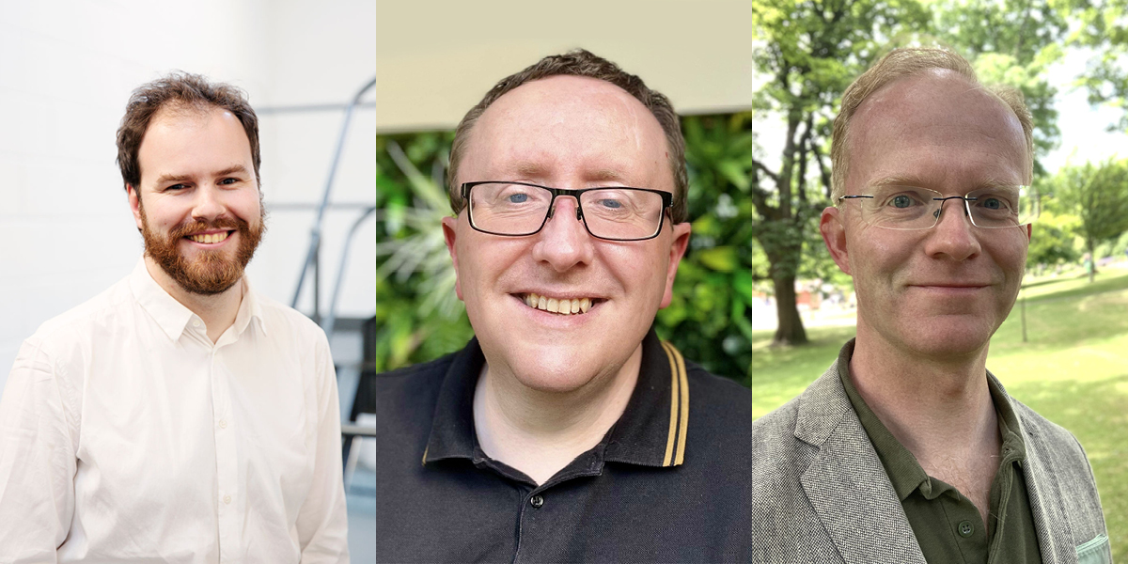

Edward Edgcumbe (left), Alan Caldwell (middle), Gregor Duthie (right).

Cumbernauld Theatre, one of Scotland's leading producing theatres, today announces the appointment of three new board members, Edward Edgcumbe, Alan Caldwell, and Gregor Duthie. These additions to the board reflect the theatre’s commitment to developing Lanternhouse as Cumbernauld's vibrant cultural hub.

Edward Edgcumbe's working life has been a patchwork of the musical and non-musical. Before joining Dunedin Consort full time as Head of Artistic Planning & Operations. Edward spent almost a decade working for a research and strategy boutique, advising senior figures in the world’s largest consulting firms on topics from acquisition strategy to sustainability.

Previously one of Dunedin Consort’s learning & participation managers, he was an Open Academy Fellow and is a co-founder of Hold the Drama, an Arts Council England supported group that creates immersive shows that use high-quality live music to tell stories that explore issues around mental health.

He holds degrees in Classics from Magdalen College, Oxford, and the Royal Academy of Music, where he studied as a countertenor with Michael Chance, Larry Zazzo, and James Baillieu.
Alan Caldwell grew up in Cumbernauld and worked in financial services for 13 years before joining the Civil Service in 2008. Over the past 15 years Alan has performed key high profile organisational roles within government, working with senior colleagues, Ministers and stakeholders, and gaining an understanding of complex and fast-paced issues and corporate responsibilities. Alan was previously a director of a professional football club, with overall responsibility for the budgeting and future direction of the company.
Gregor Duthie is a passionate advocate for the arts, drawing on personal experiences as a member of choral and theatre groups during his formative years. With a professional background as a practicing solicitor specialising in advising Scottish SMEs in the real estate sector, Gregor sees being a Board member of Cumbernauld Theatre as an opportunity to give back to the arts community. Having previously run an amateur dramatic society in Glasgow, he has been actively involved in the local arts scene since moving to Cumbernauld and Kilsyth in 2017. Impressed by the new Lanternhouse facilities and his own experience performing on its main stage, he was eager to contribute his expertise in shaping the future roadmap for this flagship building.
His commitment to fostering community engagement and celebrating the diversity of programming, coupled with his extensive professional legal and business experience, makes him an invaluable asset to the trust. Currently a Legal Director at Gilson Gray LLP, he has practiced as a solicitor for over seventeen years and brings a wealth of expertise, dedication, and a strong sense of responsibility to his role.
Sarah Price, CEO at Cumbernauld Theatre Trust, said: “I am delighted to extend a warm welcome to Edward, Alan, and Gregor as non-executive Directors of Cumbernauld Theatre. Each of them brings a wealth of expertise that will greatly benefit our work. Edward's deep knowledge of classical music and creative learning, Alan's financial acumen and governance experience, and Gregor's legal skills alongside strong ties to the local arts community, will undoubtedly enrich our collective efforts.

Together, we will continue to work passionately toward our vision of a vibrant and thriving performing arts space where memories are made and lives are transformed. I am truly excited about the possibilities that lie ahead for Cumbernauld Theatre and the positive impact we will make together.”

Karen Moore, Chair of Cumbernauld Theatre Trust, said, “It has been my utmost pleasure to serve as the Chair of Cumbernauld Theatre Trust since its relocation to Lanternhouse in 2021. As my tenure as Chair nears its end, I want to express my sincere gratitude to the dedicated team of trustees, both past and present, for their unwavering support throughout this journey. I would also like to extend a warm welcome to our new board members, Edward, Alan, and Gregor, who join us at a crucial juncture. Their remarkable energy and expertise will undoubtedly bolster our ongoing efforts to strengthen and futureproof our position within the performing arts infrastructure in Scotland. With the exceptional dedication and experience of our existing board members, Iain MacKenzie, Councillor Adam Smith, Karen McDougall, Alex Linkston and Clara Bloomfield, I have full confidence that the charity will continue to thrive under this capable leadership.”

Located in the heart of Cumbernauld, on the Cumbernauld Academy campus, this state-of-the-art venue houses two performance spaces - a 270-seat auditorium and Studio Theatre, a dance studio, an 84-seat cinema and the new North Lanarkshire Council-run café.

For more information, contact:
Rachel Murphy, Marketing & Communications for Cumbernauld Theatre: rmurphy@cumbernauldtheatre.co.uk / 01236 732887

Notes for editors

Cumbernauld Theatre Trust
Cumbernauld Theatre Trust is a performing arts charity that produces and presents professional theatre, music, dance and comedy experiences for a community of 50,000 Cumbernauld residents and 100,000 North Lanarkshire population. Established in 1963, Cumbernauld Theatre is the only professional independent arts organisation in Cumbernauld and North Lanarkshire and serves a vital social, cultural and economic purpose in a community that is economically disadvantaged, with widespread material poverty and deprivation, low academic attainment and poor-quality built environment.
As an established, professional producing theatre, we are both community-led and community conscious with activity that responds to the needs of the local community, yet we deliver outputs that achieve national and international recognition.
We aim for our work to have relevance and resonate with our audiences and participants to achieve deep and lasting impact and change. This work is informed by place, by the opportunities our new arts centre provides and by a desire to deliver affordable access to culture for everyone at all life-stages. Cumbernauld Theatre Trust is a key part of the infrastructure of Scotland’s performing arts and is a Regularly Funded Organisation (RFO) within the Creative Scotland portfolio. We receive investment in support of our work from a range of sources including Creative Scotland and North Lanarkshire Council, Weston Culture Fund and Scottish Government’s Empowering Communities Programme – Investing in Communities Fund.
Cumbernauld Theatre Trust is also supported by Screen Scotland, Equity Charitable Trust, Foyle Foundation, The Levenseat Trust, The Trades House of Glasgow Commonweal Fund, Land Trust, Robert Barr’s Charitable Trust, Hugh Fraser Foundation, The Robertson Trust and Patersons Quarries, our Friends, and donors.
Lanternhouse is a privately-owned property built through Scottish Futures Trust (SFT) investment jointly operated by North Lanarkshire Council (NLC) and Cumbernauld Theatre Trust. The construction of Lanternhouse was financed via the SFT-managed hub community infrastructure programme for local authorities in support of the Scottish Government’s National Infrastructure Mission to drive inclusive economic growth and build resilient places. For more information visit https://www.scottishfuturestrust.org.uk/.
http://www.lanternhousearts.org/ | info@lanternhousearts.org

Cumbernauld Theatre Trust Ltd is a Registered Company limited by guarantee No. SC066490, Scottish Charity OSCR Registered No. SC005050. Registered Office: Cumbernauld Theatre Trust, Lanternhouse, South Kildrum Ring Road, Cumbernauld, North Lanarkshire, G67 2UF

Lanternhouse is a registered trademark (UK00003494622) owned by Cumbernauld Theatre Trust Ltd.

