Folk favourites ready to hit the Cumbernauld stage this Autumn

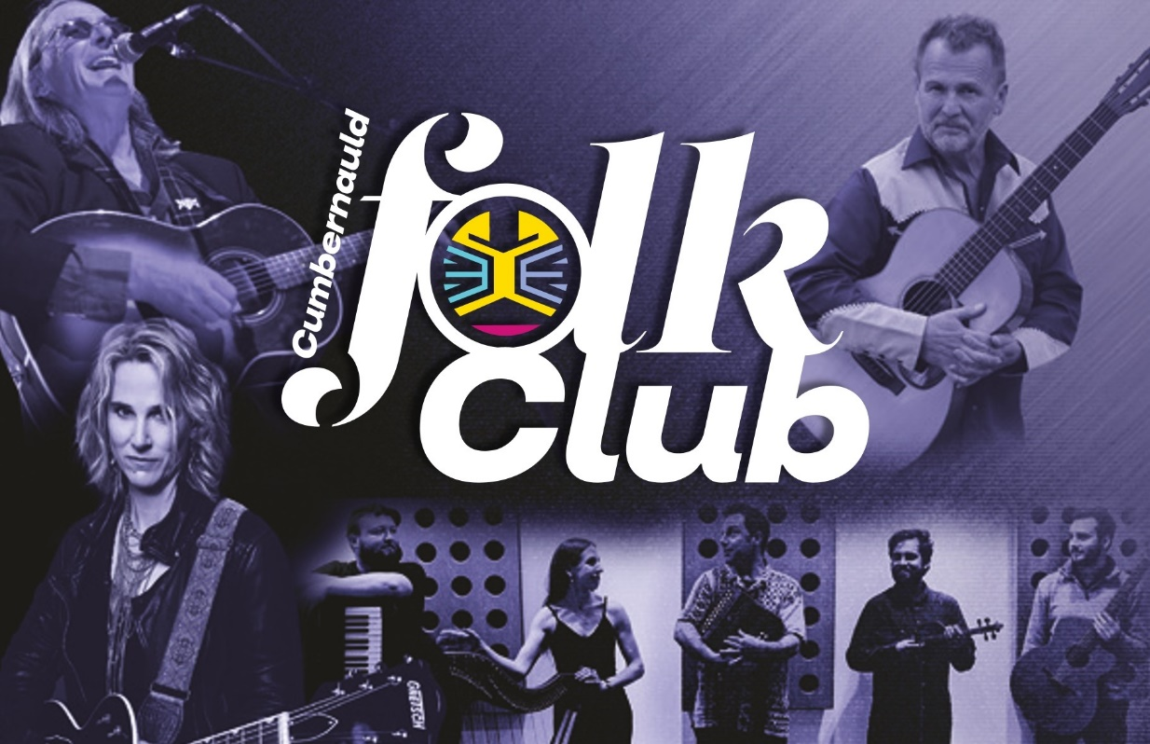
Cumbernauld audiences can look forward to nights of joyously irresistible traditional music, with a succession of folk music stars set to visit Lanternhouse this Autumn.
Aly Bain and Phil Cunningham have become a national institution with their incomparable mastery of fiddle and accordion, bringing excellence in traditional music to venues across the country. They have established themselves as the epitome of excellence in the world of traditional music, and return to the Lanternhouse stage on Friday 11 August. With their musical magic and quick-witted humour they will pull your emotional strings one moment and have you falling off the seat with laughter the next.
There’s also the return of the audience-favourite Cumbernauld Folk Club, a monthly night of traditional music, storytelling and good company with a folk headliner and support from talented local musicians. Inspired by evening events at the Cumbernauld Theatre Trust’s previous home at the Cottage Theatre, the folk club relaunched earlier this year and will bring some leading acts to the stage over the coming months.
Luke Daniels & The Cobhers bring their welcoming brand of folk music to the venue on Thursday 03 August. Formed in 2019, the band blend evocative original folk tunes with unexpected toe-tapping covers, taking on everything from Bee Gees disco classics to soul, funk, and dance hits. Following the successful release of their debut album the band is also working with Scotland’s Heritage Lottery Fund to create innovative learning materials for school children across North Lanarkshire.

World-renowned guitarist and storyteller Martin Simpson headlines on Friday 01 September. Considered one of the finest fingerstyle guitarists in the world (including being listed in Gibson Guitars’ Top 30 Acoustic Guitarists of all time), Simpson is known for his intimate solo performances that captivate audiences with passion, sorrow, love, beauty, tragedy, and majesty.
On Saturday 30 September the Folk Club welcomes legendary Scottish singer-songwriter Dougie MacLean. Undoubtably one of Scotland’s most celebrated folk musicians, MacLean’s mutli-award-winning career has seen him write enduring hits such as Caledonia and garner international recognition for his inspired performances.
Canada’s ‘Queen of Americana’ Lynne Hanson rounds out the Autumn season at the Folk Club on Tuesday 24 October. Too tough for folk and too blues-influenced for country, Hanson’s music is a unique blend of porch music, red dirt, blues, and Americana swamp. With songs that can shift suddenly from sunny ballads to gritty thunderstorms, her soulful vocals have drawn comparisons to Lucinda Williams and Gillian Welch, but it’s the poetic quality of her lyrics that truly sets her apart. Her live performances, backed by her band the Good Intentions, are high-energy, guitar-driven affairs that captivate audiences with their authenticity and charm.
Located in the heart of Cumbernauld, on the Cumbernauld Academy campus, this state-of-the-art venue houses two performance spaces - a 270-seat auditorium and Studio Theatre, a dance studio, an 84-seat cinema and the new North Lanarkshire Council-run café.
Tickets for the full programme of live performance are on sale now at www.lanternhousearts.org and by Box Office telephone bookings on 01236 732887. You can also download a brochure from the website.

ENDS -

-----------

Images for the season can be found here

For more information, contact:
Rachel Murphy, Marketing & Communications for Cumbernauld Theatre: rmurphy@cumbernauldtheatre.co.uk / 01236 732887

Notes for editors

Cumbernauld Theatre Trust
Cumbernauld Theatre Trust is a performing arts charity that produces and presents professional theatre, music, dance and comedy experiences for a community of 50,000 Cumbernauld residents and 100,000 North Lanarkshire population. Established in 1963, Cumbernauld Theatre is the only professional independent arts organisation in Cumbernauld and North Lanarkshire and serves a vital social, cultural and economic purpose in a community that is economically disadvantaged, with widespread material poverty and deprivation, low academic attainment and poor-quality built environment.
As an established, professional producing theatre, we are both community-led and community conscious with activity that responds to the needs of the local community, yet we deliver outputs that achieve national and international recognition.
We aim for our work to have relevance and resonate with our audiences and participants to achieve deep and lasting impact and change. This work is informed by place, by the opportunities our new arts centre provides and by a desire to deliver affordable access to culture for everyone at all life-stages. Cumbernauld Theatre Trust is a key part of the infrastructure of Scotland’s performing arts and is a Regularly Funded Organisation (RFO) within the Creative Scotland portfolio. We receive investment in support of our work from a range of sources including Creative Scotland and North Lanarkshire Council, Weston Culture Fund and Scottish Government’s Empowering Communities Programme – Investing in Communities Fund.
Cumbernauld Theatre Trust is also supported by Screen Scotland, Equity Charitable Trust, Foyle Foundation, The Levenseat Trust, The Trades House of Glasgow Commonweal Fund, Land Trust, Robert Barr’s Charitable Trust, Hugh Fraser Foundation, The Robertson Trust and Patersons Quarries, our Friends, and donors.
Lanternhouse is a privately-owned property built through Scottish Futures Trust (SFT) investment jointly operated by North Lanarkshire Council (NLC) and Cumbernauld Theatre Trust. The construction of Lanternhouse was financed via the SFT-managed hub community infrastructure programme for local authorities in support of the Scottish Government’s National Infrastructure Mission to drive inclusive economic growth and build resilient places. For more information visit https://www.scottishfuturestrust.org.uk/.
http://www.lanternhousearts.org/ | info@lanternhousearts.org

Cumbernauld Theatre Trust Ltd is a Registered Company limited by guarantee No. SC066490, Scottish Charity OSCR Registered No. SC005050. Registered Office: Cumbernauld Theatre Trust, Lanternhouse, South Kildrum Ring Road, Cumbernauld, North Lanarkshire, G67 2UF

Lanternhouse is a registered trademark (UK00003494622) owned by Cumbernauld Theatre Trust Ltd.

