Spring is in the air as Cumbernauld Theatre announces Spring/Summer season at Lanternhouse

Highlights of the 2024 season include:

- Cumbernauld Theatre Company brings together an evening of the very best of musical theatre with Encore!
- Strut, a collaboration with Feral Arts, brings live nighttime dance from local movers and shakers to the streets of Cumbernauld
- New visiting work from some of Scotland’s leading theatre companies including Birds of Paradise, Vanishing Point, and National Theatre of Scotland
- A brilliant programme of live comedy and music throughout the season, including monthly guests as part of Lanternhouse Laughs and the Cumbernauld Folk Club
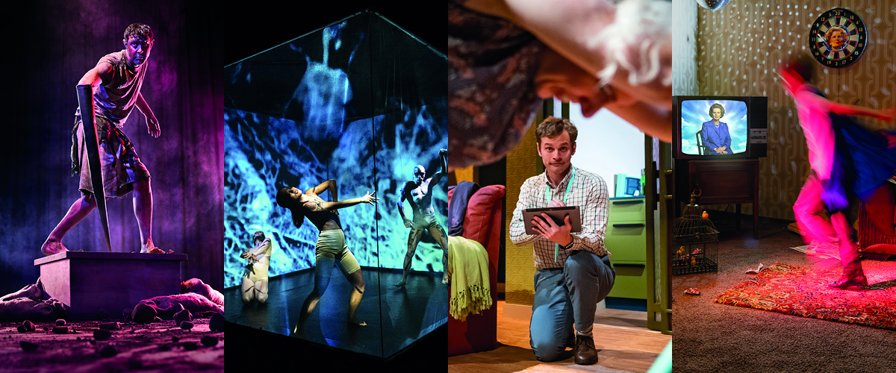

Cumbernauld Theatre has announced details of the fantastic work arriving at Lanternhouse in Spring and Summer 2024, with tickets now on sale for the season.

Following a busy festive season of stage work including family shows Ugly! A Cinderella Story and A Ladder to the Stars the Spring/Summer season runs from January to July 2024 and is packed with leading theatre, music and comedy to suit all ages and tastes.

Encore! celebrates the best in musical theatre with a sparkling evening of performances from talented singers across Scotland, brought to life by Cumbernauld Theatre Company. Whether you’re a fan of Stephen Sondheim, Andrew Lloyd Webber, or Rogers & Hammerstein, this show has something for everyone and is perfect for all musical theatre lovers.

The Lanternhouse stages will also host an exciting season of visiting theatre by some of the country’s leading companies, from the visually stunning Ruins by MHz to the riveting dark comedy Don’t. Make. Tea from Birds of Paradise. Vanishing Point and Al See Productions bring their vivid and visceral new production Plinth, KT Productions will be in residency with A Giant on the Bridge and the National Theatre of Scotland makes a welcome return with its new production, Maggie & Me.

There’s an opportunity for the community’s best movers and shakers to bring their boogying to Cumbernauld’s streets in STRUT, an exciting community collaboration with Feral Arts. Performance makers MHz are seeking five local dancers to take part in the outdoor nighttime street production – more info can be found at lanternhousearts.org/strut

There will be visiting work to keep wee visitors entertained as well. Families with young children can enjoy shows from Folksy Theatre’s take on Alice in Wonderland to delightful puppetry-led productions Myths of the Vikings and Cardboard Carnival.

Cumbernauld Theatre’s live music programme will also liven up the stage, with the return of the Cumbernauld Folk Club featuring visiting guests including Cateran, The Brothers Gillespie, Annie Dressner, and more. Dunedin Consort continues its residency at Cumbernauld Theatre to host two special relaxed concerts of beautiful baroque chamber music, specially-designed for audiences with additional support needs. There will also be musical visits from Quartet Malamatina, the Scottish National Jazz Orchestra, and many more.

Regular comedy nights also return with the monthly Lanternhouse Laughs set to guarantee belly laughter in the studio theatre, each with feature shows from comedy-circuit favourites including Jay Lafferty, Scott Agnew, Gary Little, and Bruce Fummey.

Alongside live performances, Lanternhouse Cinema continues to offer the latest blockbuster feature films and the best cinema experiences in Cumbernauld. We’ve also got world-class performances streamed from concert arenas to major theatres, including National Theatre Live and The Royal Opera House.

Sarah Price, CEO at Cumbernauld Theatre Trust, said: “It's really exciting to unveil Cumbernauld Theatre's 2024 Spring programme, brimming with theatre, dance, music , and more. At times such as these, when there is so much conflict and trouble in the world, it is especially important for us to come together and celebrate our rich and diverse culture together. Our programme has something in it for everyone and everyone is invited to take part, so please, join us, bring your friends and lets make good times happen!”

Located in the heart of Cumbernauld, on the Cumbernauld Academy campus, this state-of-the-art venue houses two performance spaces - a 270-seat auditorium and Studio Theatre, a dance studio, an 84-seat cinema and the new North Lanarkshire Council-run café.

Tickets for the full programme of live performance and creative learning activities are on sale now at www.lanternhousearts.org and by Box Office telephone bookings on 01236 732887. You can also download a brochure from the website.

ENDS/

-----------

Images for the season

For more information, contact:
Rachel Murphy, Marketing & Communications for Cumbernauld Theatre: rmurphy@cumbernauldtheatre.co.uk / 01236 732887

Notes for editors

Cumbernauld Theatre Trust
Cumbernauld Theatre Trust is a performing arts charity that produces and presents professional theatre, music, dance and comedy experiences for a community of 50,000 Cumbernauld residents and 100,000 North Lanarkshire population. Established in 1963, Cumbernauld Theatre is the only professional independent arts organisation in Cumbernauld and North Lanarkshire and serves a vital social, cultural and economic purpose in a community that is economically disadvantaged, with widespread material poverty and deprivation, low academic attainment and poor-quality built environment.
As an established, professional producing theatre, we are both community-led and community conscious with activity that responds to the needs of the local community, yet we deliver outputs that achieve national and international recognition.
We aim for our work to have relevance and resonate with our audiences and participants to achieve deep and lasting impact and change. This work is informed by place, by the opportunities our new arts centre provides and by a desire to deliver affordable access to culture for everyone at all life-stages. Cumbernauld Theatre Trust is a key part of the infrastructure of Scotland’s performing arts and is a Regularly Funded Organisation (RFO) within the Creative Scotland portfolio. We receive investment in support of our work from a range of sources including Creative Scotland and North Lanarkshire Council, Weston Culture Fund and Scottish Government’s Empowering Communities Programme – Investing in Communities Fund.
Cumbernauld Theatre Trust is also supported by Screen Scotland, Equity Charitable Trust, Foyle Foundation, The Levenseat Trust, The Trades House of Glasgow Commonweal Fund, Land Trust, Robert Barr’s Charitable Trust, Hugh Fraser Foundation, The Robertson Trust and Patersons Quarries, our Friends, and donors.
Lanternhouse is a privately-owned property built through Scottish Futures Trust (SFT) investment jointly operated by North Lanarkshire Council (NLC) and Cumbernauld Theatre Trust. The construction of Lanternhouse was financed via the SFT-managed hub community infrastructure programme for local authorities in support of the Scottish Government’s National Infrastructure Mission to drive inclusive economic growth and build resilient places. For more information visit https://www.scottishfuturestrust.org.uk/.
http://www.lanternhousearts.org/ | info@lanternhousearts.org

Cumbernauld Theatre Trust Ltd is a Registered Company limited by guarantee No. SC066490, Scottish Charity OSCR Registered No. SC005050. Registered Office: Cumbernauld Theatre Trust, Lanternhouse, South Kildrum Ring Road, Cumbernauld, North Lanarkshire, G67 2UF

Lanternhouse is a registered trademark (UK00003494622) owned by Cumbernauld Theatre Trust Ltd.

