Cumbernauld Theatre celebrates seasonal success with Ugly: A Cinderella Story and teases first festive details for 2024
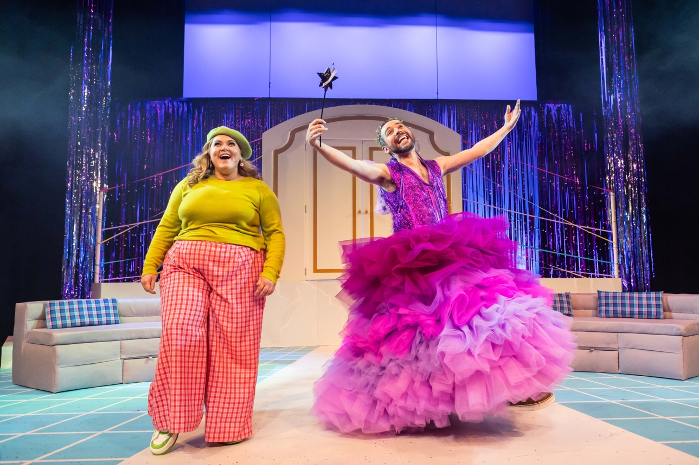
Laurence Boothman and Lauren Ellis Steele in Ugly: A Cinderella Story – pic by Sally Jubb
Following the success of main stage show Ugly: A Cinderella Story, Cumbernauld Theatre has today revealed the first details of the new festive productions that audiences can look forward to seeing on the Lanternhouse stage in 2024.
Writer Gary McNair’s heartwarming and unforgettable new spin on the classic Cinderella story, which saw the Ugly Sister Chantelle team up with the Fairy Godmother to finally get her own transformative wish, was a huge hit with audiences of all ages throughout December.
Over the show’s 45 performances more than 8,500 people stepped in to enjoy the festive magic of Wondernauld, making this Lanternhouse’s most successful main stage festive production to date.
The show was brought to life by a glittering cast of theatre talent including Lauren Ellis Steele as Chantelle, Jo Freer as Maw, Laurence Boothman as the Prince and Fairy Godmother, and Eva Beattie making her professional stage debut as Cinderella. Directed by Jo Rush, the production also featured memorable music by Brian James O’Sullivan.

And Cumbernauld Theatre is delighted to reveal that Christmas 2024 will see Gary McNair return to write a new take on Pinocchio for the main stage at Lanternhouse. The delightful new production, also featuring music by Brian James O’Sullivan, will run at the theatre from 23 Nov to 29 Dec 2024.
The Studio Theatre at Lanternhouse will also host a brand-new production for younger children and families. A collaboration between Cumbernauld Theatre Company, Visible Fictions and Scottish Opera, Special Delivery will be an enchanting musical journey filled with wonder for little ones ages 3 – 7. Written by Clive King, directed by Dougie Irvine, and featuring music by Karen McIver, the show will run from 30 Nov to 29 Dec 2024.

ENDS/

-----------
For more information, contact:
Rachel Murphy, Communications & Engagement Manager, Cumbernauld Theatre: rmurphy@cumbernauldtheatre.co.uk / 01236 732887

Notes for editors
Cumbernauld Theatre Trust
Cumbernauld Theatre Trust is a performing arts charity that produces and presents professional theatre, music, dance and comedy experiences for a community of 50,000 Cumbernauld residents and 100,000 North Lanarkshire population. Established in 1963, Cumbernauld Theatre is the only professional independent arts organisation in Cumbernauld and North Lanarkshire and serves a vital social, cultural and economic purpose in a community that is economically disadvantaged, with widespread material poverty and deprivation, low academic attainment and poor-quality built environment.
As an established, professional producing theatre, we are both community-led and community conscious with activity that responds to the needs of the local community, yet we deliver outputs that achieve national and international recognition.
We aim for our work to have relevance and resonate with our audiences and participants to achieve deep and lasting impact and change. This work is informed by place, by the opportunities our new arts centre provides and by a desire to deliver affordable access to culture for everyone at all life-stages. Cumbernauld Theatre Trust is a key part of the infrastructure of Scotland’s performing arts and is a Regularly Funded Organisation (RFO) within the Creative Scotland portfolio. We receive investment in support of our work from a range of sources including Creative Scotland and North Lanarkshire Council, Weston Culture Fund and Scottish Government’s Empowering Communities Programme – Investing in Communities Fund.
Cumbernauld Theatre Trust is also supported by Screen Scotland, Equity Charitable Trust, Foyle Foundation, The Levenseat Trust, The Trades House of Glasgow Commonweal Fund, Land Trust, Robert Barr’s Charitable Trust, Hugh Fraser Foundation, The Robertson Trust and Patersons Quarries, our Friends, and donors.
Lanternhouse is a privately-owned property built through Scottish Futures Trust (SFT) investment jointly operated by North Lanarkshire Council (NLC) and Cumbernauld Theatre Trust. The construction of Lanternhouse was financed via the SFT-managed hub community infrastructure programme for local authorities in support of the Scottish Government’s National Infrastructure Mission to drive inclusive economic growth and build resilient places. For more information visit https://www.scottishfuturestrust.org.uk/.
http://www.lanternhousearts.org/ | info@lanternhousearts.org
Cumbernauld Theatre Trust Ltd is a Registered Company limited by guarantee No. SC066490, Scottish Charity OSCR Registered No. SC005050. Registered Office: Cumbernauld Theatre Trust, Lanternhouse, South Kildrum Ring Road, Cumbernauld, North Lanarkshire, G67 2UF
Lanternhouse is a registered trademark (UK00003494622) owned by Cumbernauld Theatre Trust Ltd.

