Jack Nurse announced as Director for Cumbernauld Theatre’s Autumn production The Events
- Jack Nurse, Director and Co-Founder of Wonder Fools, has been appointed Director of Cumbernauld Theatre’s Autumn production of The Events by David Grieg
- At Lanternhouse from 28 September to 5 October 2024
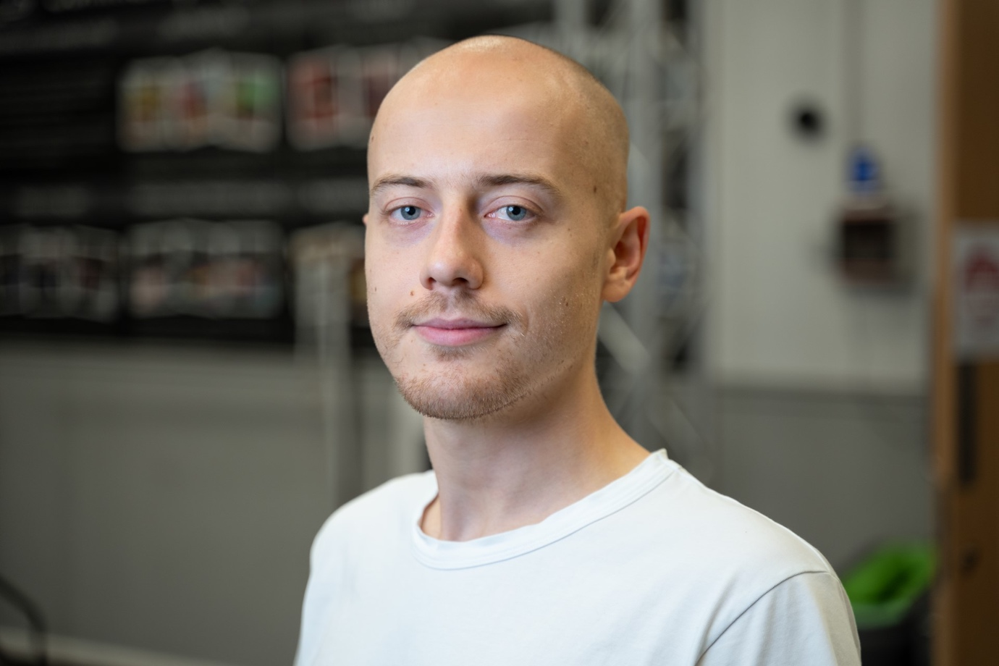
Jack Nurse
Today Cumbernauld Theatre announces the Director for its upcoming autumn production The Events, a restaging of the powerful play from writer David Grieg.
When Claire, a priest, survives an atrocity she sets out on a quest to answer the most difficult question of all: ‘Why?’ The Events is a journey that takes her to the edge of reason, science, politics and faith. David Greig’s 2013 play explores our destructive desire to fathom the unfathomable and asks how far forgiveness can stretch in the face of brutality.
The Events was commissioned and first produced by Actors Touring Company in co-production with the Young Vic Theatre, Schauspielhaus Wein and Brageteatret. It premiered at the Traverse Theatre, Edinburgh, in August 2013. Cumbernauld Theatre is staging this new production as a powerful means of exploring and understanding the complex themes of community, grief, and resilience in the face of tragedy. This play, with its profound narrative and emotional depth, offers a unique opportunity for both the actors and the audience to engage in a meaningful dialogue about contemporary social issues. By bringing The Events to the stage now, Cumbernauld Theatre is not only showcasing its commitment to presenting thought-provoking and relevant theatre but also providing a space for reflection and healing in today's challenging times.
This new adaptation, led by Director Jack Nurse, will be an exciting collaboration between a professional cast and community choir, specifically created for this new production. We will be actively seeking performers from all walks of life to join us onstage to help tell this powerful story.
Director Jack Nurse said: ‘I am delighted to be working with Cumbernauld Theatre to bring David Greig’s brilliant play to life. The Events is an urgent, searching and quietly daring piece that has only gained in significance since it first premiered. I am particularly looking forward to working with the local community during the creative process and collaborating to make a show that speaks directly to the world we live in whilst being rooted in Cumbernauld.’
Creative Producer Fraser Morrison said: ’We are excited to appoint Jack in this role to bring The Events to the Cumbernauld Theatre stage this Autumn. We were excited by Jack’s expertise and experience in combining high-quality contemporary theatre with an honest and considered community engagement process – making him the ideal person to handle this sensitive and timely production.’
The Events will run at Lanternhouse Main Auditorium from Tue 1 October to Sat 5 October, with an opening press performance on Sat 28 September at 7:30pm. Tickets will be on sale with Cumbernauld Theatre’s Autumn/Winter season in May 2024.

ENDS/

-----------
For more information, contact:
Rachel Murphy, Marketing & Communications Manager, Cumbernauld Theatre: rmurphy@cumbernauldtheatre.co.uk / 01236 732887

Director Biography
Jack Nurse
Jack is a director and theatre-maker. He co-founded Glasgow-based theatre company Wonder Fools in 2014.
Jack was recently an Origins Artist with Headlong (2021-2) and is currently Creative Engagement Director at the Ayr Gaiety, Artist in Residence (Creative Development) at the Traverse Theatre and artistic lead of the international participatory project Positive Stories for Negative Times.
Training: Royal Conservatoire of Scotland and the National Theatre Studio Directors’ Course.
As Director/Writer:
549: Scots of the Spanish Civil War, The Coolidge Effect (Wonder Fools); When the Sun Meets the Sky (Traverse Theatre/Capital Theatres)

As Director:
And Then Come the Nightjars (Wonder Fools); Lampedusa (Citizens Theatre/Wonder Fools); Meet Jan Black (Wonder Fools/Ayr Gaiety); The Essence of the Job is Speed (Almeida Theatre); Larchview (National Theatre of Scotland); The Lost Elves (Citizens Theatre/RCS); The Mack, The Storm (Play, Pie, Pint/Traverse Theatre).
As Associate/Assistant Director:
Red Dust Road (National Theatre of Scotland/HOME); The Broons (Sell A Door); Dr Dolittle (Music & Lyrics); Oresteia: This Restless House (Citizens Theatre/National Theatre of Scotland), Blackbird (Citizens Theatre); The Winter’s Tale (Royal Lyceum); Hay Fever (Royal Lyceum/Citizens Theatre).
www.jacknurse.com

Notes for editors
Cumbernauld Theatre Trust
Cumbernauld Theatre Trust is a performing arts charity that produces and presents professional theatre, music, dance and comedy experiences for a community of 50,000 Cumbernauld residents and 100,000 North Lanarkshire population. Established in 1963, Cumbernauld Theatre is the only professional independent arts organisation in Cumbernauld and North Lanarkshire and serves a vital social, cultural and economic purpose in a community that is economically disadvantaged, with widespread material poverty and deprivation, low academic attainment and poor-quality built environment.
As an established, professional producing theatre, we are both community-led and community conscious with activity that responds to the needs of the local community, yet we deliver outputs that achieve national and international recognition.
We aim for our work to have relevance and resonate with our audiences and participants to achieve deep and lasting impact and change. This work is informed by place, by the opportunities our new arts centre provides and by a desire to deliver affordable access to culture for everyone at all life-stages. Cumbernauld Theatre Trust is a key part of the infrastructure of Scotland’s performing arts and is a Regularly Funded Organisation (RFO) within the Creative Scotland portfolio. We receive investment in support of our work from a range of sources including Creative Scotland and North Lanarkshire Council, Weston Culture Fund and Scottish Government’s Empowering Communities Programme – Investing in Communities Fund.
Cumbernauld Theatre Trust is also supported by Screen Scotland, Equity Charitable Trust, Foyle Foundation, The Levenseat Trust, The Trades House of Glasgow Commonweal Fund, Land Trust, Robert Barr’s Charitable Trust, Hugh Fraser Foundation, The Robertson Trust and Patersons Quarries, our Friends, and donors.
Lanternhouse is a privately-owned property built through Scottish Futures Trust (SFT) investment jointly operated by North Lanarkshire Council (NLC) and Cumbernauld Theatre Trust. The construction of Lanternhouse was financed via the SFT-managed hub community infrastructure programme for local authorities in support of the Scottish Government’s National Infrastructure Mission to drive inclusive economic growth and build resilient places. For more information visit https://www.scottishfuturestrust.org.uk/.
http://www.lanternhousearts.org/ | info@lanternhousearts.org
Cumbernauld Theatre Trust Ltd is a Registered Company limited by guarantee No. SC066490, Scottish Charity OSCR Registered No. SC005050. Registered Office: Cumbernauld Theatre Trust, Lanternhouse, South Kildrum Ring Road, Cumbernauld, North Lanarkshire, G67 2UF
Lanternhouse is a registered trademark (UK00003494622) owned by Cumbernauld Theatre Trust Ltd.

