Cumbernauld Theatre announces new Season at Lanternhouse

Highlights of the season include:

- The autumn in-house production in association with Wonder Fools of The Events by David Grieg, featuring a collaboration between the professional cast and a specially created Community Choir.
- The premiere of a magical family show taking to the stage this Christmas: Pinocchio, based on the classic children’s novel and written by Gary McNair.
- Special Delivery, co-produced with Visible Fictions and Scottish Opera, an enchanting musical journey filled with wonder this winter for ages 3-7.
- Exciting visiting theatre from some of Scotland’s leading companies, including Thank U, Next, Love Beyond and To Save The Sea.

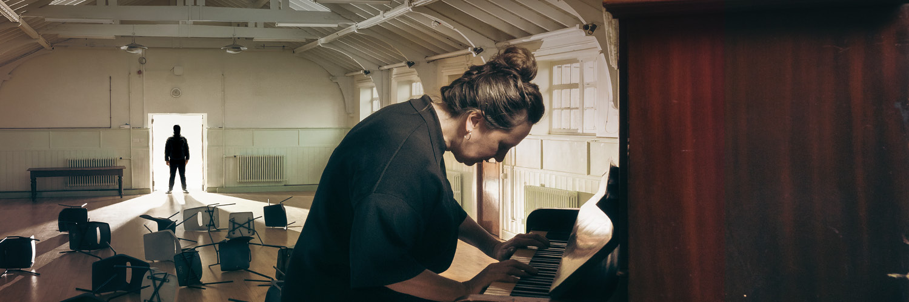

Cumbernauld Theatre has announced the details of fantastic original productions and new work from leading companies this autumn and winter, with tickets now on sale for all shows.
The Events is a compelling new production from Cumbernauld Theatre Company in association with Wonder Fools of David Grieg’s modern classic. Directed by Jack Nurse, The Events follows Claire, a priest who survives a mass shooting, as she embarks on a journey that tests her faith, reason, and understanding of politics and science. This production features a unique collaboration between the professional cast and a Community Choir created for the show.

Throughout December, the Cumbernauld Theatre stages will host festive fun for all the family, with two spellbinding productions. The Main Stage will feature Pinocchio, a raucous, entertaining journey written by Gary McNair, directed by Laila Noble, with music by Brian James O’Sullivan. Meanwhile the Studio Theatre will present Special Delivery, an enchanting musical journey following Santa and a mischievous hitchhiker, co-produced by Cumbernauld Theatre Company, Visible Fictions, and Scottish Opera.

The Autumn season will also feature visiting productions from some of Scotland’s leading theatre companies. Love Beyond by Ramesh Meyyappen, a Raw Material and Vanishing Point co-production in association with Aberdeen Performing Arts, about a man with dementia forgetting sign language. Other highlights include Thank U, Next from the National Theatre of Scotland, in association with Cumbernauld Theatre Company and Cumbernauld Academy, and Sleeping Warrior’s new Greenpeace-inspired musical To Save the Sea.

There will be visiting work to keep young audiences entertained as well. Families can enjoy shows including Treasure Island, written by Ross McKay and directed by Jordan Blackwood, originally produced by Cumbernauld Theatre Company and Visible Fictions, the return of The Amazing Bubble Man, Artie’s Singing Kettle Greatest Hits and Legendary magician the Great Baldini in The Family Magic Show.

Cumbernauld Theatre’s live music programme will also liven up the stage, with the return of Cumbernauld Folk Club featuring visiting guests including Robin Adams, Peggy Seeger and Nick Harper. National treasures Aly Bain & Phil Cunningham will also return, and contemporary jazz from the Fergus McCreadie Trio will make its first visit to Lanternhouse.

Regular comedy nights also return with the monthly Lanternhouse Laughs, featuring shows from comedy-circuit favourites including Christopher MacArthur-Boyd, Gary Faulds and Scottish Comedy Collective.

In addition to live performances, Lanternhouse Cinema continues to offer the latest blockbuster films and top-notch cinematic experiences. There will also be world-class performance streams from venues like National Theatre Live and The Royal Opera House, along with special cinematic events and sing-alongs.

Fraser Morrison, Creative Producer at Cumbernauld Theatre, said: “We are excited to unveil our new season at Lanternhouse, filled with a rich and diverse array of theatre, music, and comedy. In these challenging times, it's more important than ever to come together and celebrate our shared culture and community spirit. Our programme offers something for everyone—from the compelling drama of The Events to the festive fun of Pinocchio and Special Delivery. We invite everyone to join us, bring friends and family, and create memorable moments together.”

Located in the heart of Cumbernauld, on the Cumbernauld Academy campus, this state-of-the-art venue houses two performance spaces - a 270-seat auditorium and Studio Theatre, a dance studio, an 84-seat cinema and the new North Lanarkshire Council-run café.

Tickets for the full programme of live performance and creative learning activities are on sale now at www.lanternhousearts.org and by Box Office telephone bookings on 01236 732887. You can also download a brochure from the website.

ENDS/

-----------

Images for the season can be found here.

For more information, contact:
Rachel Murphy, Marketing & Communications for Cumbernauld Theatre: rmurphy@cumbernauldtheatre.co.uk / 01236 732887

Notes for editors

Listings information for Cumbernauld Theatre Company productions

The Events
Sat 28 September – Sat 5 October (press night Tue 2 Oct)
For tickets to press night contact marketing@cumbernauldtheatre.co.uk.
For tickets and further information call the box office on 01236 732887 or visit lanternhousearts.org/events/the-events

Pinocchio
Sat 23 November – Sun 29 December (press night Thu 28 Nov)
For tickets to press night contact marketing@cumbernauldtheatre.co.uk.
For tickets and further information call the box office on 01236 732887 or visit lanternhousearts.org/events/pinocchio

Special Delivery
Sat 28 September – Sat 5 October (press performance 6 December)
For tickets to a press performance contact marketing@cumbernauldtheatre.co.uk.
For tickets and further information call the box office on 01236 732887 or visit lanternhousearts.org/events/special-delivery

Cumbernauld Theatre Trust
Cumbernauld Theatre Trust is a performing arts charity that produces and presents professional theatre, music, dance and comedy experiences for a community of 50,000 Cumbernauld residents and 100,000 North Lanarkshire population. Established in 1963, Cumbernauld Theatre is the only professional independent arts organisation in Cumbernauld and North Lanarkshire and serves a vital social, cultural and economic purpose in a community that is economically disadvantaged, with widespread material poverty and deprivation, low academic attainment and poor-quality built environment.
As an established, professional producing theatre, we are both community-led and community conscious with activity that responds to the needs of the local community, yet we deliver outputs that achieve national and international recognition.
We aim for our work to have relevance and resonate with our audiences and participants to achieve deep and lasting impact and change. This work is informed by place, by the opportunities our new arts centre provides and by a desire to deliver affordable access to culture for everyone at all life-stages. Cumbernauld Theatre Trust is a key part of the infrastructure of Scotland’s performing arts and is a Regularly Funded Organisation (RFO) within the Creative Scotland portfolio. We receive investment in support of our work from a range of sources including Creative Scotland and North Lanarkshire Council, Weston Culture Fund and Scottish Government’s Empowering Communities Programme – Investing in Communities Fund.
Cumbernauld Theatre Trust is also supported by Screen Scotland, Equity Charitable Trust, Foyle Foundation, The Levenseat Trust, The Trades House of Glasgow Commonweal Fund, Land Trust, Robert Barr’s Charitable Trust, Hugh Fraser Foundation, The Robertson Trust and Patersons Quarries, our Friends, and donors.
Lanternhouse is a privately-owned property built through Scottish Futures Trust (SFT) investment jointly operated by North Lanarkshire Council (NLC) and Cumbernauld Theatre Trust. The construction of Lanternhouse was financed via the SFT-managed hub community infrastructure programme for local authorities in support of the Scottish Government’s National Infrastructure Mission to drive inclusive economic growth and build resilient places. For more information visit https://www.scottishfuturestrust.org.uk/.
http://www.lanternhousearts.org/ | info@lanternhousearts.org

Cumbernauld Theatre Trust Ltd is a Registered Company limited by guarantee No. SC066490, Scottish Charity OSCR Registered No. SC005050. Registered Office: Cumbernauld Theatre Trust, Lanternhouse, South Kildrum Ring Road, Cumbernauld, North Lanarkshire, G67 2UF

Lanternhouse is a registered trademark (UK00003494622) owned by Cumbernauld Theatre Trust Ltd.

