Cast announced for The Events by David Greig
- Claire Lamont and Sam Stopford will star in the compelling new production of The Events
- Written by David Greig, Directed by Jack Nurse, Music by John Browne
- At Cumbernauld Theatre from Saturday 28 September to Saturday 5 October
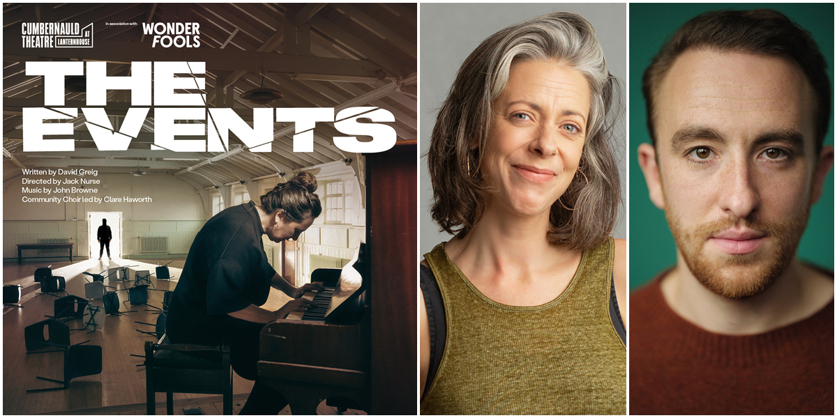
The Events cast – Claire Lamont and Sam Stopford
Today the cast is announced for the upcoming autumn production The Events, a compelling new production from Cumbernauld Theatre Company in association with Wonder Fools, of David Greig’s modern classic.
When Claire, a priest, survives a violent a mass shooting in a peaceful community she embarks on a quest to answer the most difficult question of all: 'Why?'. The Events takes her to the edge of reason, science, politics, and faith.
This hugely timely and poignant play offers a deeply moving and thought-provoking experience. The production also features an exciting collaboration between our professional cast and a specially-created Community Choir from residents across North Lanarkshire.
The show will be brought to life by leading theatre talent Claire Lamont and Sam Stopford. The play, written by David Greig will be led by Director Jack Nurse, with music by John Browne, set and costume by Becky Minto, lighting design by Lizzie Powell and the Community Choir led by Claire Haworth.
Director Jack Nurse said: “I’m beyond thrilled to be directing The Events – an incredible play that although first produced over ten years ago feels like it was written for today. Alongside the play’s urgency it’s a privilege to collaborate with such a fantastic cast, creative team and specially created choir from the local area. This production has everything I love about making theatre: vital themes and a community focus. I cannot wait to bring the play to life and create a moving, thought provoking and compelling night out for audiences.”
Producer Fraser Morrison said: "The Events is a deeply significant play that resonates powerfully with current global issues, exploring themes of violence, community, and healing. We are incredibly excited to bring this vital revival to the stage in Cumbernauld. With our talented cast and creative team, and the enthusiastic participation of the local community choir, this production promises to be both a thought-provoking and emotional experience. It's an honour to present a work that speaks so urgently to the times we live in and to do so with such a dedicated and skilled team."
The Events will run at Lanternhouse Main Auditorium from Sat 28 September to Sat 30 October, with an opening press performance on Tue 1 October at 7.30pm.
ENDS/

-----------
Cast images and biogs can be found here.
For more information, contact:
Rachel Murphy, Communications & Communication Manager, Cumbernauld Theatre:
rmurphy@cumbernauldtheatre.co.uk / 01236 732887
Serden Salih, Head of Marketing & Communications, Wonder Fools:
serden@wonderfools.org / 01236 732887

Production info
The Events
Written by David Greig, Directed by Jack Nurse, Music by John Browne, Community Choir led by Claire Haworth
Presented by Cumbernauld Theatre Company in association with Wonder Fools

Cast:
Claire – Claire Lamont
The Boy – Sam Stopford

Creative Team:
Writer – David Greig
Director – Jack Nurse
Composer – John Browne
Community Choir Director – Claire Howarth

Listings info

Saturday 28 September – Saturday 5 October at 7.30pm and Saturday 5 October at 2.30pm:
Preview performance on Sat 28 September, 7.30pm
Press Performance on Tuesday 1 October, 7.30pm
Audio Described Performance on Friday 4 October, 7.30pm
Ticket prices: £10 - £17

For tickets and full listings information call the box office on 01236 732887 or visit https://lanternhousearts.org

Biographies
Claire Lamont (Claire)
Claire Lamont is an Actor and Theatre Maker from Belfast, Northern Ireland. Claire trained at the Royal Scottish Academy of Music and Drama graduating in 2001. Claire has since worked as an Actor, Director and Theatre Maker with a variety of companies in Scotland, the UK and Internationally. Claire led the BA Performance course in BSL and English from its inception in 2015 until 2022 and is currently an Associate Director (ENGAGE) with Dundee Rep and Scottish Dance Theatre.
Sam Stopford (The Boy)
Sam Stopford is a graduate of the Royal Conservatoire of Scotland.
His credits include: Measure for Measure; Hedda Gabler; Henry IV, Lear’s Fool; Jekyll and Hyde; A Midsummer Night’s Dream; Much Ado About Nothing (all Bard in the Botanics); Faye’s Red Lines; Sally (both A Play, a Pie and a Pint); Alfold (Glasgow Citizen’s); The Metamorphosis (Vanishing Point); Middletown, The Lost Elves, Cymbeline, The Breathing House, The Seagull, Frankie and Johnny in the Clair de Lune (all RCS).
Sam is the recipient of the James Bridie Gold Medal for the best performance in BA Acting, Royal Conservatoire of Scotland 2020, Winner of the Duncan Macrae Competition prize 2019 and recipient of the Arnold Fleming Scholarship.
David Greig (Writer)
David Greig is a multi award-winning playwright who became the Artistic Director of the Royal Lyceum Edinburgh in 2015. David’s most notable plays include The Events, The Strange Undoing of Prudencia Hart, Midsummer, Dunsinane and Europe. More recently, David’s new stage adaptation of Solaris, based on Stanislaw Lem’s 1961 soviet science fiction novel, was co-produced by The Lyceum, Malthouse Theatre in Melbourne Australia and The Lyric Hammersmith. In 2019 David teamed up with original creators Bill Forsyth and Mark Knopfler to adapt the international hit film Local Hero for the stage which premiered in Edinburgh. David’s new stage adaptation of Joe Simpson's best-selling 1988 memoir Touching the Void, which was co-produced by The Lyceum and Bristol Old Vic, enjoyed a run at The Duke of York in London’s West End in 2019/20. His other adaptations include Strindberg’s Creditors (2018) and Aeschylus’ The Suppliant Women (2016) The Lorax (2015). David wrote the book for Charlie and the Chocolate Factory, which opened in the West End in 2013 and then transferred to Broadway in 2017.
Jack Nurse (Director)
Jack is a director and theatre-maker. He co-founded Glasgow-based theatre company Wonder Fools in 2014.

Training: Royal Conservatoire of Scotland and the National Theatre Studio Directors’ Course
As Writer: Same Team: A Street Soccer Story (Traverse Theatre)
As Director/Writer: 549: Scots of the Spanish Civil War, The Coolidge Effect (Wonder Fools); When the Sun Meets the Sky (Traverse Theatre/Capital Theatres)
As Director: 24 (Day): The Measure of My Dreams and The Essence of the Job is Speed (Almeida Theatre) Òran and And Then Come the Nightjars (Wonder Fools); Lampedusa (Citizens Theatre/Wonder Fools); Meet Jan Black (Wonder Fools/Ayr Gaiety); (Almeida Theatre); Larchview (National Theatre of Scotland/BBC Scotland); The Lost Elves (Citizens Theatre/RCS); The Mack, The Storm (Play, Pie, Pint/Traverse Theatre)
www.jacknurse.com

Notes for editors
Cumbernauld Theatre Trust
Uniting through sustainable arts for positive change in Scotland
Cumbernauld Theatre Trust is a performing arts charity that produces and presents professional theatre, music, dance and comedy experiences for a community of 50,000 Cumbernauld residents and 100,000 North Lanarkshire population. Established in 1963, Cumbernauld Theatre is the only professional independent arts organisation in Cumbernauld and North Lanarkshire and serves a vital social, cultural and economic purpose in a community that is economically disadvantaged, with widespread material poverty and deprivation, low academic attainment and poor-quality built environment.
As an established, professional producing theatre, we are both community-led and community conscious with activity that responds to the needs of the local community, yet we deliver outputs that achieve national and international recognition.
We aim for our work to have relevance and resonate with our audiences and participants to achieve deep and lasting impact and change. This work is informed by place, by the opportunities our new arts centre provides and by a desire to deliver affordable access to culture for everyone at all life-stages. Cumbernauld Theatre Trust is a key part of the infrastructure of Scotland’s performing arts and is a Regularly Funded Organisation (RFO) within the Creative Scotland portfolio. We receive investment in support of our work from a range of sources including Creative Scotland and North Lanarkshire Council, Weston Culture Fund and Scottish Government’s Empowering Communities Programme – Investing in Communities Fund.
Cumbernauld Theatre Trust is also supported by Screen Scotland, Equity Charitable Trust, Foyle Foundation, The Levenseat Trust, The Trades House of Glasgow Commonweal Fund, Land Trust, Robert Barr’s Charitable Trust, Hugh Fraser Foundation, The Robertson Trust and Patersons Quarries, our Friends, and donors.
Lanternhouse is a privately-owned property built through Scottish Futures Trust (SFT) investment jointly operated by North Lanarkshire Council (NLC) and Cumbernauld Theatre Trust. The construction of Lanternhouse was financed via the SFT-managed hub community infrastructure programme for local authorities in support of the Scottish Government’s National Infrastructure Mission to drive inclusive economic growth and build resilient places. For more information visit https://www.scottishfuturestrust.org.uk/.
http://www.lanternhousearts.org/ | info@lanternhousearts.org
Cumbernauld Theatre Trust Ltd is a Registered Company limited by guarantee No. SC066490, Scottish Charity OSCR Registered No. SC005050. Registered Office: Cumbernauld Theatre Trust, Lanternhouse, South Kildrum Ring Road, Cumbernauld, North Lanarkshire, G67 2UF
Lanternhouse is a registered trademark (UK00003494622) owned by Cumbernauld Theatre Trust Ltd.

Wonder Fools
Wonder Fools (WF) are a socially engaged theatre company and registered charity.
Since its inception in 2017, Wonder Fools has a proven track record of delivering high quality arts projects through the three strands of our programme:
– co-creating ambitious theatre productions with young people and communities
– producing innovative artist development initiatives
– delivering ground breaking creative engagement projects
We are a deeply passionate and creatively restless young theatre company. We are based in Glasgow, but our impact extends across Scotland, the UK, and around the world. We tour our productions and projects throughout Scotland and have a broader national and international presence through Positive Stories for Negative Times.
Since 2020 alone our work has reached:
- 30,803 digital audience
- 9080 live audiences
- 1300 workshop attendees
- 10,000 Positive Stories for Negative Times participants
- 18 countries

