Cast announced for Cumbernauld Theatre’s new festive show Pinocchio
- Julia Murray, Cole Stewart, Stephanie MacGaraidh and Caitlin Forbes will star in the charming festive production this winter
- Written by Gary McNair, Directed by Laila Noble, and Music by Brian James O’Sullivan
- At Lanternhouse from Saturday 23 November to Sunday 29 December
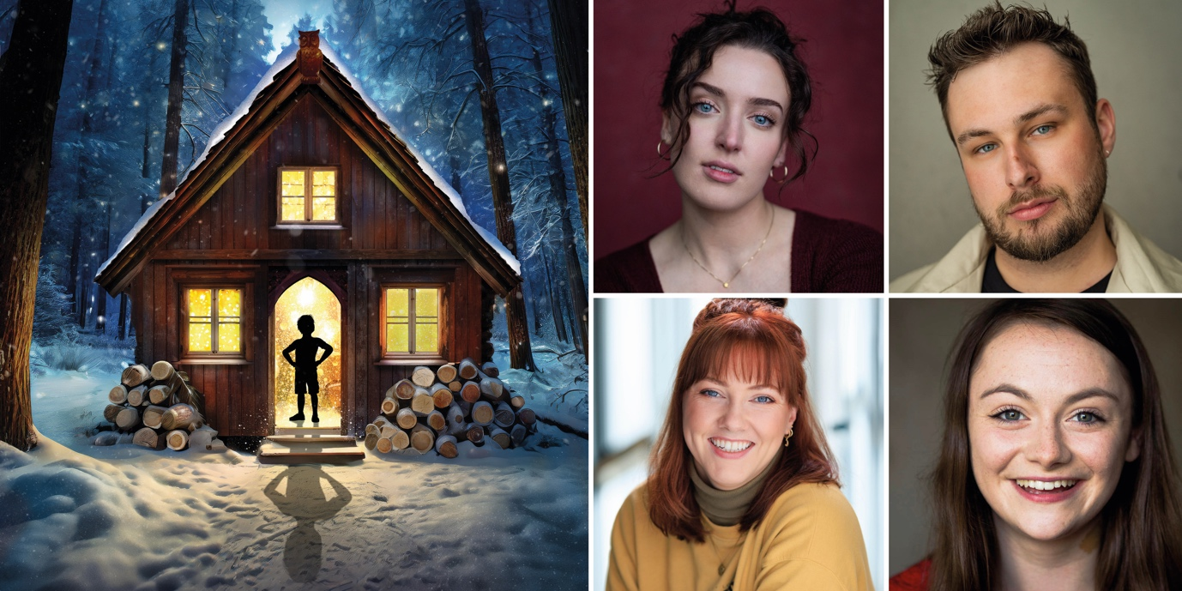
Pinocchio cast – Julia Murray, Cole Stewart, Stephanie MacGaraidh and Caitlin Forbes

Today Cumbernauld Theatre announces the cast for its upcoming festive show Pinocchio, a brand-new raucous take on the story written by Gary McNair.
All Pinocchio has ever wanted is to be a real boy. But hold on…if he wants things, surely that means he has thoughts and feelings. And if he has thoughts and feelings, then doesn’t that mean he has a brain and a heart? And if he has all that, doesn’t that make him a real boy already?
He lives a fun and happy but very protected life with his wild and entertaining granny, Gepetta who wants to keep him safe and sheltered from the outside world.
But he can only stay safe and sheltered for so long. Will he ever make it to the outside world? And if so, what kind of magical adventures will he go on? Well, yes he does and you’ll need to come along to find out.
This silly and hugely entertaining journey will be brought to life by theatre talent Julia Murray as Pinocchio, Cole Stewart as Gepetta/Fairy Godmother, Stephanie MacGaraidh as Hingwy/Salesman/Stomboli/Whale and Caitlin Forbes as Mozart/Honest Sean/90’s guy/Passerby/Clicky. The production, written by Gary McNair, will be led by Director Laila Noble, with music by Brian James O’Sullivan and design by Fraser Lappin.
Writer Gary McNair said: ‘I’ve always enjoyed performing in Cumbernauld, it’s a special theatre that always has a great atmosphere. So it’s a total delight to be returning to write for this year's festive show after all the fun we had last year. The audiences are always amazing and I can’t wait to bring this new production to them. We are incredibly lucky to have Julia, Cole, Stephanie and Caitlin on board- they’re a hilarious and talented group of actors, who will bring Pinocchio to life with sparkle and joy. I'm really looking forward to the fun to start in rehearsals and to meeting the crowds soon!’
Executive Producer Ken Alexander said: ‘We are thrilled with the quality of the cast that the Creative Team for ‘Pinocchio’ have been able to put together. Cumbernauld audiences are in for a treat this Christmas with this fun packed show, which is full of comedy, music and adventure’.
Pinocchio will run at Lanternhouse Main Auditorium from Sat 23 November to Sun 29 December, with an opening press performance on Thu 28 November at 7pm.
Meanwhile the Studio Theatre welcomes a magical production for younger audiences from Sat 30 Nov to Sun 29 Dec, Special Delivery, a co-production from Cumbernauld Theatre Company, Visible Fictions and Scottish Opera.
ENDS/

-----------
Cast images and biogs can be found here.
For more information, contact:
Rachel Murphy, Marketing & Communications Manager, Cumbernauld Theatre:
rmurphy@cumbernauldtheatre.co.uk / 01236 732887
Margot Law-Mckay, Digital Marketing and Communications Assistant
Mlawmckay@cumbernauldtheatre.co.uk / 01236 732887
Production info
Pinocchio
Written by Gary McNair, Directed by Laila Noble, Music by Brian James O’Sullivan, Design by Fraser Lappin
A Cumbernauld Theatre Company Production

Cast:
Julia Murray – Pinocchio
Cole Stewart – Gepetta / Fairy Godmother
Stephanie MacGaraidh – Hingwy, Salesman / Stomboli / Whale
Caitlin Forbes – Mozart / Honest Sean / 90’s Guy / Passerby / Clicky

Creative Team:
Writer – Gary McNair
Director – Laila Noble
Composer – Brian James O’Sullivan
Designer – Fraser Lappin

Listings info

Saturday 23 November – Sunday 29 December:
Preview Performance on Sat 23 November, 7pm
Press Performance on Thu 28 November at 7pm
Relaxed Performances on Wed 11 December at 2.30pm and Sun 15 December at 1.30pm
Audio Described Performance on Wed 18 December at 7pm
Signed Performance on Thu 19 December at 7pm
Ticket prices: £7.50 - £25

For tickets and full listings information call the box office on 01236 732887 or visit https://lanternhousearts.org

Biographies
Julia Murray
Julia trained at the Royal Conservatoire of Scotland and was the BA Musical Theatre Programme Prize Recipient 2020.

Recent Theatre credits include: Sleeping Beauty (Ayr Gaiety), Impromptu (Play Pie Pint), Underwood Lane (Tron Theatre), Thread (Kick the Door), Robin Hood (Cumbernauld Theatre), Rehearsed Readings with The Tron (The Grain Store) and Traverse Theatre (Cow & Pig), and City of Angles, The Baker’s Wife, Assasins, Pippin, Don’t Wait Too Long, Please , Bon Apetit (Royal Conservatoire of Scotland).
Julia Murray
Pinocchio
Julia trained at the Royal Conservatoire of Scotland and was the BA Musical Theatre Programme Prize Recipient 2020. Recent Theatre Credits include: Bootcut (UK Tour); Islander (UK/US tour); Sleeping Beauty (Ayr Gaeity);Impromptu (A Play, a Pie and a Pint); Underwood Lane (Tron Theatre); Thread (Kick the Door); Robin Hood (Cumbernauld Theatre).
Cole Stewart
Gepetta / Fairy Godmother
Cole is an actor, vocalist, voiceover and writer from Glasgow. Since graduating from New College Lanarkshire in 2022 with a BA in Acting, he has performed in many of Scotland's leading producing houses such as the Citizens Theatre, Traverse Theatre, Edinburgh Royal Lyceum Theatre, Tron Theatre, Cumbernauld Theatre, Oran Mor and at sea.
Recent credits include: A Cracking Cinderella Story (Websters Theatre), The Wonderful Wizard of Oz (Tron Theatre), A Daurk Maiter, Scarfed for Life (Citizens Theatre), Hard Times (Traverse Theatre), Sea Hear (P&O).
Credits while in training: Buckets, Dracula, A Night to Remember, Treasure Island, Alice in Pantoland, Ushers the Front of House Musical & Vanity Fair.
This is Cole’s first Christmas season in Lanternhouse and he can’t wait for you all to join him in Gepetta’s workshop!
Stephanie MacGaraidh
Hingwy, Salesman / Stomboli / Whale
Steph is an actor, singer-songwriter and musician from the east coast of Scotland, who graduated from Guildford School of Acting in 2018. She is thrilled to be returning to Cumbernauld Theatre, and hopes you enjoy the show!
Recent credits include: Arran in Islander (UK/US Tour), Mistress Ford & Others/Musician in Merry Wives of Windsor (Folksy Theatre Summer Tour), Swing in A Mother’s Song (Macrobert Arts Centre), Billie Bones/Captain Smollett/Musician/Puppeteer in Treasure Island (Cumbernauld Theatre Company & 2024 Scottish Tour), Swing in Friends! The Musical Parody (UK & Ireland Tour), Grace O’Malley/Antonia in The Sea Queen/Twelfth Night (Gods and Monsters Theatre at The Scoop, London), Moth/Maria in Love’s Labour’s Lost (Oxford Shakespeare Company).
Other Credits Include: Eilidh in What Are We Called? (Blotched Ink Productions, Short Film), Ellory in The Last Delivery (Westminster Film School, Short Film), First Witch and others in MacBeth (award winning audio drama, Almost Tangible).
Caitlin Forbes
Mozart / Honest Sean / 90’s Guy / Passerby / Clicky
Caitlin graduated with a BA Musical Theatre from the Royal Conservatoire of Scotland in 2021.
Her recent credits include: Danni in Daring to Dig (The Audio Story Company), Sandra in 90 Days (So Strong Productions), Belle/Charity Lady Nelly/Turkey Boy in A Christmas Carol (Dundee Rep/Noisemaker), Fiona in The Stamping Ground (Eden Court Highlands/Raw Material), Ginny in Mother Goose (Glasgow Life), Young Vi in Violet, Jack’s Mother in Into the Woods, Virginia in The Pajama Game, Vocalist in What If: An Evening of New Musical Theatre Writing, Actor Musician in Cinderella, Nurse in Takin' Over the Asylum (Royal Conservatoire of Scotland), Kimberlee in Tanya: A New Musical (Royal Conservatoire of Scotland/O’Neill & Savage), Ensemble in Beauty and the Beast (South Lanarkshire Leisure & Culture). Workshop credits include: Fan in Flora (Michelle McKay), Mary in The Edinburgh 7 (Aria Entertainment & John Stalker Productions Ltd) and Actor in Club Supreme (Ramshacklicious).
Gary McNair
Writer
Gary McNair is a writer and performer from Glasgow. He aims to make work that will entertain and challenge audiences in equal measure. His work has been translated into several languages and performed around the world from America to Australia, Germany to Japan, and from Portugal to Possilpark. He is a mainstay of the Edinburgh Fringe where his last seven shows have sold out and he has won the coveted Scotsman Fringe First Award three times.
He is Writer in Residence at the National Theatre of Scotland and is an Associate Artist at both the Traverse Theatre in Edinburgh and the Tron in Glasgow. He loves telling stories and is delighted that people want to hear them.
Recent works include; Dear Billy (National Theatre of Scotland), Nae Expectations (The Tron) Jekyll and Hyde (Reading Rep/The Lyceum) Black Diamonds and the Blue Brazil (The Lyceum), The Alchemist (The Tron), Square Go [co-authored by Kieran Hurley] (Francesca Moody Productions/Paines Plough), McGonagall’s Chronicles(Oran Mor), Locker Room Talk/Letters to Morrissey (The Traverse) A Gambler’s Guide To Dying (Show and Tell/The Traverse). Many of these titles and more are available from bloomsbury.com
Brian James O’Sullivan
Composer
Brian is a composer, actor and comedian from Glasgow. Recent composing work includes “The Thinkery” and “My Name is Sarah and…” As a comedian, he recently completed his solo trilogy, “Uh Huh: The Janice & Frank Story” (parts I, II and III) and as an actor is currently appearing in “Macbeth” (Donmar Warehouse) and was the recipient of Best Dame in the UK Pantomime Awards 2022.

