**MSP visits Cumbernauld Theatre in celebration of The Living Wage Week 2024**

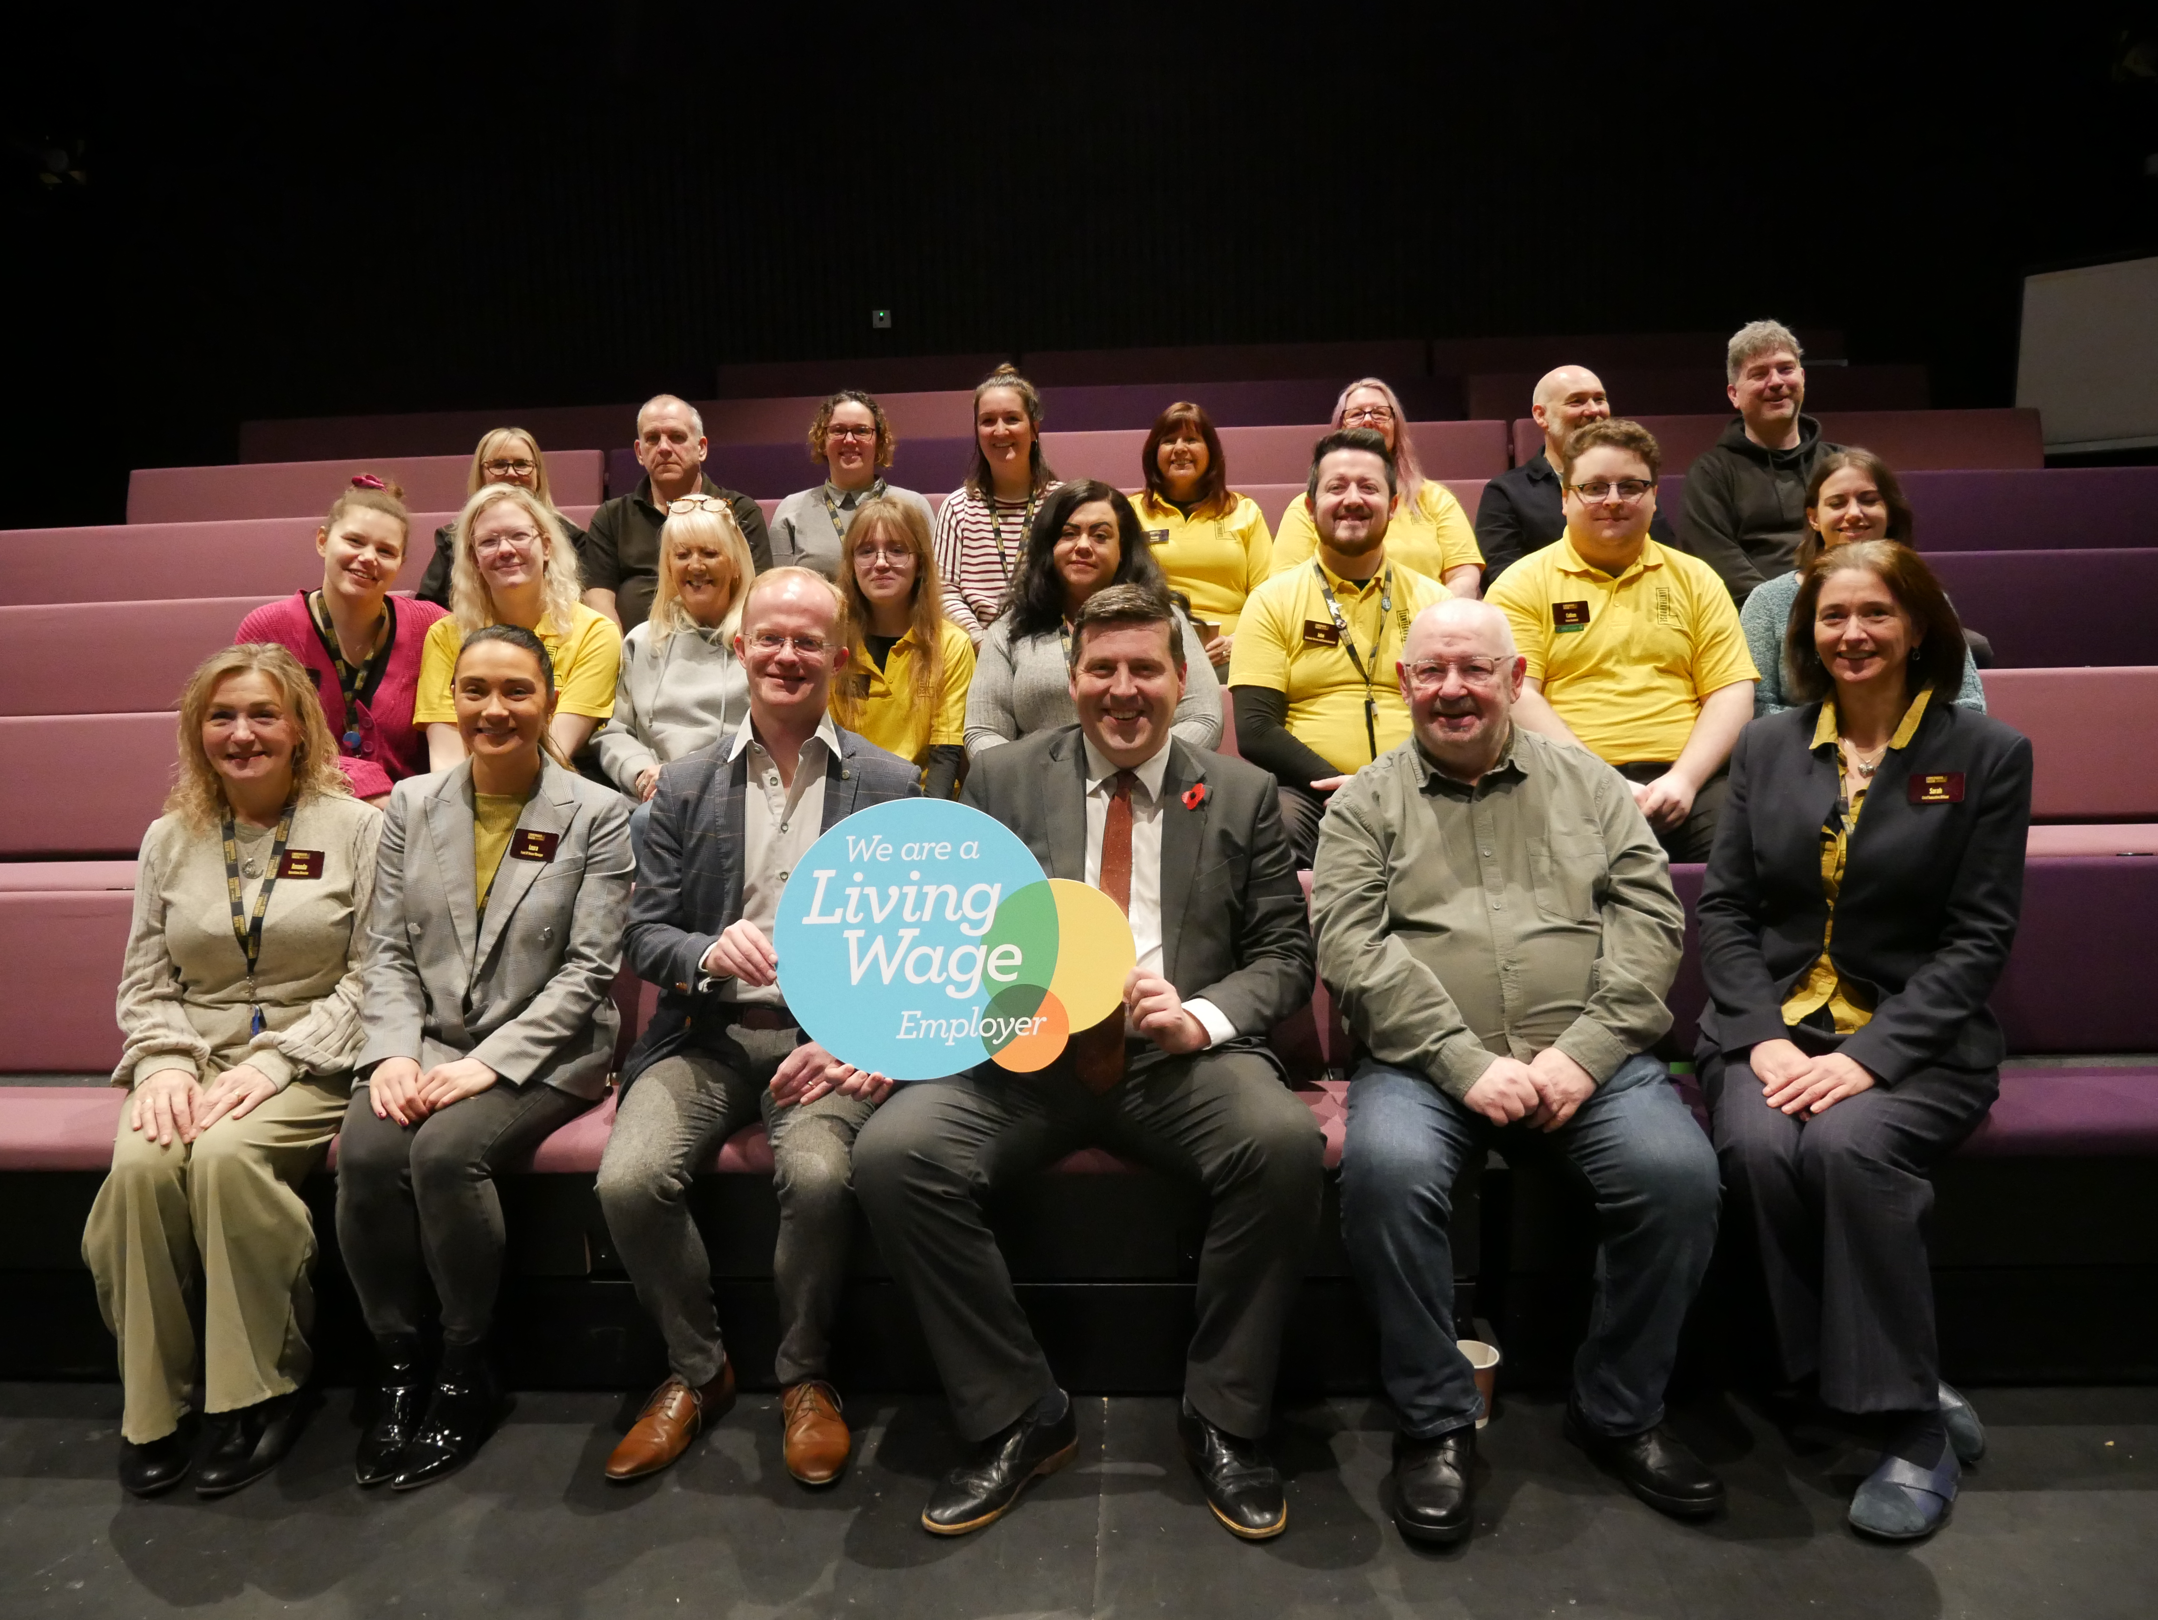*Holding the sign, from left to right: Gregor Duthie, Cumbernauld Theatre Board Member and Jamie Hepburn MSP. Also pictured, on the right: Iain Mackenzie, Cumbernauld Theatre Board Member and Sarah Price, CEO of Cumbernauld Theatre, as well as staff of Cumbernauld Theatre.*

Today Cumbernauld Theatre hosted a visit from Jamie Hepburn MSP, who visited the theatre to discuss the real Living Wage, in celebration of Living Wage Week 2024.

The real Living Wage is the only UK wage rate which is based on the cost of living. This scheme, which is voluntarily paid by over 15,000 UK businesses, recognises that a hard day’s work deserves a fair day’s pay.

Accredited Living Wage Employer Cumbernauld Theatre is committed to regularly reviewing the real living wage to ensure continued alignment with fair compensation standards.

**Sarah Price, CEO of Cumbernauld Theatre said**: *“Today was an opportunity for us to recognise the importance of the Real Living Wage to our employees and give our continued commitment to Fairwork at Cumbernauld Theatre.”*

This visit from Jamie Hepburn MSP, who was accompanied by Real Living Wage representative (name) was an opportunity to celebrate Cumbernauld Theatre’s commitment to the movement, to engage in conversations around fair pay in the industry and discuss its impact at Cumbernauld Theatre.

**Jamie Hepburn MSP said**: *“Payment of the real living wage is a great demonstration of commitment to fair work and I am grateful to the many employers across Scotland and in Cumbernauld and Kilsyth in particular. Having Cumbernauld Theatre, who are a really important part of the social fabric of the local area, committed to the real living wage is absolutely fantastic.*

*Of course not only is commitment to the real living wage good for the employee but so too is it good for the employer, helping with improved productivity and increased retention of staff. I would encourage all employers to commit to the real living wage as an investment in their workforce and in their business.”*

Cumbernauld Theatre, located in the heart of Cumbernauld Theatre, is a thriving hub of creativity, which houses two performance spaces; a 270 seat auditorium and Studio Theatre, a dance studio, an 84-seat cinema and the new North Lanarkshire Council-run café.

**ENDS**

**Notes for editors**

**For more information, contact:**

**Rachel Murphy, Marketing & Communications for Cumbernauld Theatre:** rmurphy@cumbernauldtheatre.co.uk / 01236 732887

**More pictures:** [here](https://drive.google.com/drive/folders/16dU19WmqLIoo3LdiYgAM2RLab01R6h23?usp=sharing)

**Cumbernauld Theatre Trust**  
Cumbernauld Theatre Trust is a performing arts charity that produces and presents professional theatre, music, dance and comedy experiences for a community of 50,000 Cumbernauld residents and 100,000 North Lanarkshire population. Established in 1963, Cumbernauld Theatre is the only professional independent arts organisation in Cumbernauld and North Lanarkshire and serves a vital social, cultural and economic purpose in a community that is economically disadvantaged, with widespread material poverty and deprivation, low academic attainment and poor-quality built environment.

As an established, professional producing theatre, we are both community-led and community conscious with activity that responds to the needs of the local community, yet we deliver outputs that achieve national and international recognition.

We aim for our work to have relevance and resonate with our audiences and participants to achieve deep and lasting impact and change. This work is informed by place, by the opportunities our new arts centre provides and by a desire to deliver affordable access to culture for everyone at all life-stages. Cumbernauld Theatre Trust is a key part of the infrastructure of Scotland’s performing arts and is a Regularly Funded Organisation (RFO) within the Creative Scotland portfolio. We receive investment in support of our work from a range of sources including Creative Scotland and North Lanarkshire Council, Weston Culture Fund and Scottish Government’s Empowering Communities Programme – Investing in Communities Fund.

Cumbernauld Theatre Trust is also supported by Screen Scotland, Equity Charitable Trust, Foyle Foundation, The Levenseat Trust, The Trades House of Glasgow Commonweal Fund, Land Trust, Robert Barr’s Charitable Trust, Hugh Fraser Foundation, The Robertson Trust and Patersons Quarries, our Friends, and donors.

Lanternhouse is a privately-owned property built through Scottish Futures Trust (SFT) investment jointly operated by North Lanarkshire Council (NLC) and Cumbernauld Theatre Trust. The construction of Lanternhouse was financed via the SFT-managed hub community infrastructure programme for local authorities in support of the Scottish Government’s National Infrastructure Mission to drive inclusive economic growth and build resilient places. For more information visit <https://www.scottishfuturestrust.org.uk/>.

<http://www.lanternhousearts.org/> | [info@lanternhousearts.org](mailto:%E2%80%AFinfo@lanternhousearts.org)

Cumbernauld Theatre Trust Ltd is a Registered Company limited by guarantee No. SC066490, Scottish Charity OSCR Registered No. SC005050. Registered Office: Cumbernauld Theatre Trust, Lanternhouse, South Kildrum Ring Road, Cumbernauld, North Lanarkshire, G67 2UF

Lanternhouse is a registered trademark (UK00003494622) owned by Cumbernauld Theatre Trust Ltd.