Cumbernauld Theatre Responds to Creative Scotland Funding Decision
- Cumbernauld Theatre Trust loses crucial Creative Scotland funding – The theatre’s application for Multi-Year Funding was unsuccessful, putting its future at risk.
- Impact on community and arts programme – The decision threatens the theatre’s ability to continue producing Scottish theatre, supporting artists, and engaging 40,000+ people annually.
- Call for public support – Cumbernauld Theatre Trust urges audiences and stakeholders to stand with them as they explore ways to secure their future, including applying for short-term transition funding.
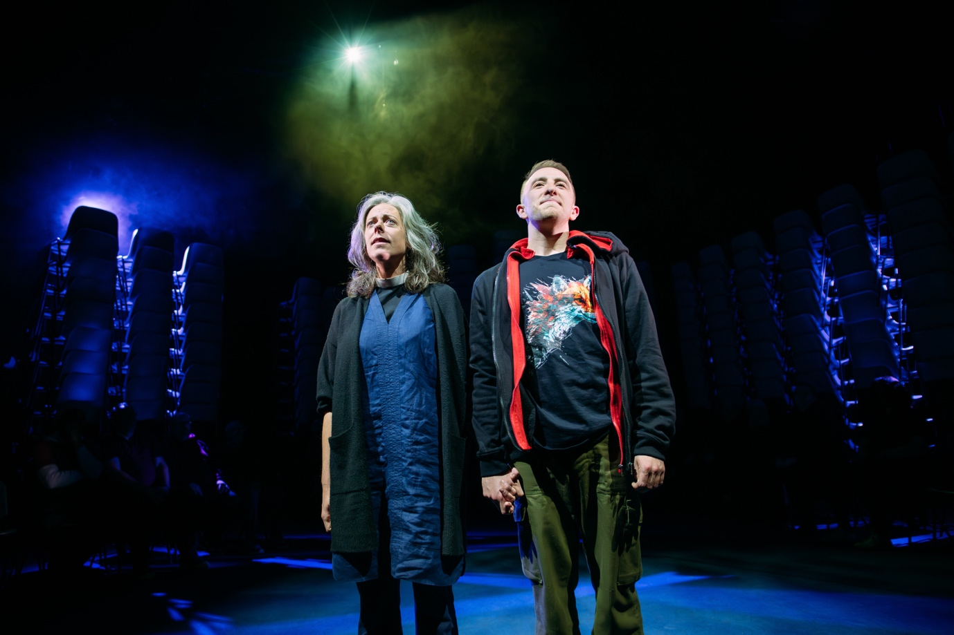
The Events by David Grieg © Cumbernauld Theatre, 2024. Photo by Mihaela Bodlovic.

Cumbernauld Theatre Trust is deeply disappointed to learn that our application to Creative Scotland’s Multi-Year Funding Programme has not been successful. This decision is devastating for our organisation, our staff, and the communities we serve, as it threatens our ability to continue delivering the rich artistic and cultural experiences that have made Cumbernauld Theatre a cornerstone of Scotland’s performing arts sector.
For over 50 years, Cumbernauld Theatre has been a home for original Scottish theatre-making, innovative live performance, and a thriving participatory arts programme. Every year, we welcome over 40,000 audience members, artists, and participants into our venue, offering a diverse and inclusive artistic programme that inspires, challenges, and enriches lives. This funding decision places all of this at risk.
Chief Executive Sarah Price said: ‘We are heartbroken by this decision. Cumbernauld Theatre is a vital part of Scotland’s cultural landscape, dedicated to telling important Scottish stories, supporting artists, and making the arts accessible to all. We know the value of what we do – the joy it brings, the opportunities it creates, and the impact it has on our community. While this decision is devastating, we remain committed to exploring every possible avenue to secure the future of our theatre.’
What This Means for Cumbernauld Theatre
This funding was essential to ensuring that Cumbernauld Theatre could continue to produce and present theatre at the scale and ambition we had planned. While we will apply for the Transition Fund offered by Creative Scotland, this is short-term support and does not replace the long-term stability that multi-year funding would have provided. Over the coming weeks, we will be reviewing our future plans and considering how we move forward in the wake of this decision. We will also be working closely with our partners, funders, and supporters to identify new ways to sustain our artistic and community programmes.

A Call to Action for Our Audiences and Supporters
At this critical time, we need our community more than ever. Cumbernauld Theatre has always been more than just a venue – it is a space where people come together, where creativity flourishes, and where stories are shared. We will be calling on our audiences, supporters, and stakeholders to stand with us as we fight for the future of our theatre.

We are grateful for the unwavering support of the artists, audiences, participants, and partners who believe in the power of theatre to transform lives. We urge those who care about the future of cultural life in Scotland to continue to advocate for the arts, ensuring that communities like ours do not lose the vital creative spaces they rely on.

We will provide further updates as we navigate this challenging period. In the meantime, we encourage our audiences to continue attending performances, engaging with our work, and championing the role of theatre in Scotland’s cultural life.

ENDS/

-----------
A selection of press images can be found here.
For more information, contact:
Rachel Murphy, Marketing & Communications Manager, Cumbernauld Theatre:
rmurphy@cumbernauldtheatre.co.uk / 01236 807 494

Notes for editors
Cumbernauld Theatre Trust
Cumbernauld Theatre Trust is a performing arts charity that produces and presents professional theatre, music, dance and comedy experiences for a community of 50,000 Cumbernauld residents and 100,000 North Lanarkshire population. Established in 1963, Cumbernauld Theatre is the only professional independent arts organisation in Cumbernauld and North Lanarkshire and serves a vital social, cultural and economic purpose in a community that is economically disadvantaged, with widespread material poverty and deprivation, low academic attainment and poor-quality built environment.
As an established, professional producing theatre, we are both community-led and community conscious with activity that responds to the needs of the local community, yet we deliver outputs that achieve national and international recognition.
We aim for our work to have relevance and resonate with our audiences and participants to achieve deep and lasting impact and change. This work is informed by place, by the opportunities our new arts centre provides and by a desire to deliver affordable access to culture for everyone at all life-stages. Cumbernauld Theatre Trust is a key part of the infrastructure of Scotland’s performing arts and is a Regularly Funded Organisation (RFO) within the Creative Scotland portfolio. We receive investment in support of our work from a range of sources including Creative Scotland and North Lanarkshire Council, Weston Culture Fund and Scottish Government’s Empowering Communities Programme – Investing in Communities Fund.
Cumbernauld Theatre Trust is also supported by Screen Scotland, Equity Charitable Trust, Foyle Foundation, The Levenseat Trust, The Trades House of Glasgow Commonweal Fund, Land Trust, Robert Barr’s Charitable Trust, Hugh Fraser Foundation, The Robertson Trust and Patersons Quarries, our Friends, and donors.
Lanternhouse is a privately-owned property built through Scottish Futures Trust (SFT) investment jointly operated by North Lanarkshire Council (NLC) and Cumbernauld Theatre Trust. The construction of Lanternhouse was financed via the SFT-managed hub community infrastructure programme for local authorities in support of the Scottish Government’s National Infrastructure Mission to drive inclusive economic growth and build resilient places. For more information visit https://www.scottishfuturestrust.org.uk/.
http://www.lanternhousearts.org/ | info@lanternhousearts.org
Cumbernauld Theatre Trust Ltd is a Registered Company limited by guarantee No. SC066490, Scottish Charity OSCR Registered No. SC005050. Registered Office: Cumbernauld Theatre Trust, Lanternhouse, South Kildrum Ring Road, Cumbernauld, North Lanarkshire, G67 2UF
Lanternhouse is a registered trademark (UK00003494622) owned by Cumbernauld Theatre Trust Ltd.

