**Cumbernauld Theatre opens applications for their Christmas Appeal 2024**

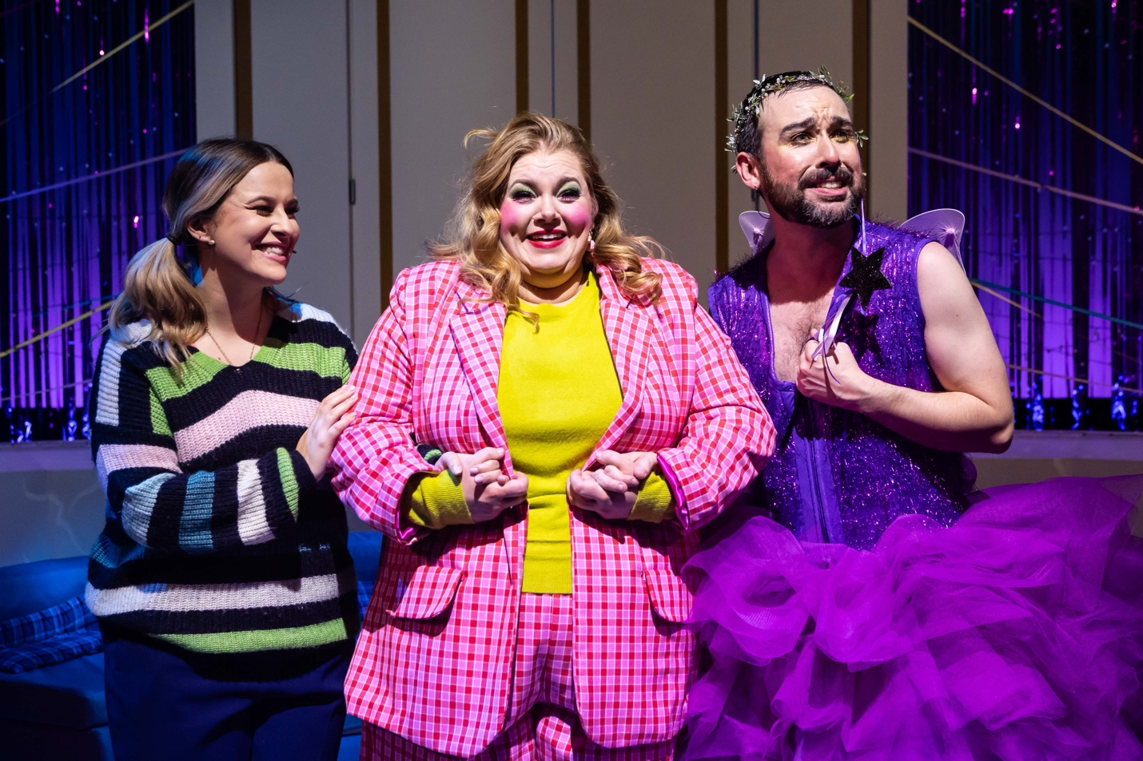*The cast of Cumbernauld Theatre’s 2023 festive show, Ugly! A Cinderella Story*

[**Link for Christmas Appeal 2024 applications**](https://lanternhousearts.org/christmas-appeal-application/)

Cumbernauld Theatre Company has opened applications for its 2024 Christmas Appeal, offering tickets to festive productions productions [Pinocchio](https://lanternhousearts.org/events/cumbernauld-folk-club-presents-the-brothers-gillespie/) (for ages 7+) and [Special Delivery](https://lanternhousearts.org/events/special-delivery/) (for ages 3 - 7).

Funded by the generosity of supporters throughout the year, the appeal aims to share the magic of live theatre with individuals and families who may not otherwise have the opportunity to attend. Local groups and organisations serving those in need are encouraged to apply.

Last year, over 300 tickets were donated to the community. Thanks to incredible support throughout the year, enough funds have already been raised to exceed this figure, ensuring even more families can experience Cumbernauld’s festive shows this season.

**Sarah Price, CEO, said** *‘For many people in our communities, experiencing the joy of attending Christmas shows is sometimes just out of reach. As a charity, Cumbernauld Theatre has raised funds through our Christmas Appeal 2024 that will give a gift of a ticket to attend either Pinocchio or Special Delivery at Cumbernauld Theatre to those from our community that may need some extra support this Christmas. The excitement and joy we witness when audiences join us for some festive fun at Cumbernauld Theatre is truly heartwarming, and we hope to spread that feeling to many children, young people, and families in our communities this December’*

**How to Apply**  
Applications are open to local groups and organisations serving individuals and families in need. To submit an application, visit [**lanternhousearts.org/christmas-appeal**](http://lanternhousearts.org/christmas-appeal). The deadline for applications is 10am on Monday, 16 December 2024. Due to limited availability, not all requests may be fulfilled.

**How to Donate**  
Donations to the appeal can also be made via [**lanternhousearts.org/christmas-appeal**](http://lanternhousearts.org/christmas-appeal) or by contacting the box office at 01236 732 887. Every contribution directly supports offering tickets to those who may not otherwise have the chance to attend.

**ENDS**

**Link to the Christmas Appeal can be found** [**here**](https://lanternhousearts.org/christmas-appeal-application/)

**Notes for Editors**

**For more information, contact:**

Rachel Murphy, Marketing & Communications for Cumbernauld Theatre:rmurphy@cumbernauldtheatre.co.uk / 01236 732887

**Cumbernauld Theatre Trust**  
Cumbernauld Theatre Trust is a performing arts charity that produces and presents professional theatre, music, dance and comedy experiences for a community of 50,000 Cumbernauld residents and 100,000 North Lanarkshire population. Established in 1963, Cumbernauld Theatre is the only professional independent arts organisation in Cumbernauld and North Lanarkshire and serves a vital social, cultural and economic purpose in a community that is economically disadvantaged, with widespread material poverty and deprivation, low academic attainment and poor-quality built environment.

As an established, professional producing theatre, we are both community-led and community conscious with activity that responds to the needs of the local community, yet we deliver outputs that achieve national and international recognition.

We aim for our work to have relevance and resonate with our audiences and participants to achieve deep and lasting impact and change. This work is informed by place, by the opportunities our new arts centre provides and by a desire to deliver affordable access to culture for everyone at all life-stages. Cumbernauld Theatre Trust is a key part of the infrastructure of Scotland’s performing arts and is a Regularly Funded Organisation (RFO) within the Creative Scotland portfolio. We receive investment in support of our work from a range of sources including Creative Scotland and North Lanarkshire Council, Weston Culture Fund and Scottish Government’s Empowering Communities Programme – Investing in Communities Fund.

Cumbernauld Theatre Trust is also supported by Screen Scotland, Equity Charitable Trust, Foyle Foundation, The Levenseat Trust, The Trades House of Glasgow Commonweal Fund, Land Trust, Robert Barr’s Charitable Trust, Hugh Fraser Foundation, The Robertson Trust and Patersons Quarries, our Friends, and donors.

Lanternhouse is a privately-owned property built through Scottish Futures Trust (SFT) investment jointly operated by North Lanarkshire Council (NLC) and Cumbernauld Theatre Trust. The construction of Lanternhouse was financed via the SFT-managed hub community infrastructure programme for local authorities in support of the Scottish Government’s National Infrastructure Mission to drive inclusive economic growth and build resilient places. For more information visit <https://www.scottishfuturestrust.org.uk/>.

<http://www.lanternhousearts.org/> | [info@lanternhousearts.org](mailto:%E2%80%AFinfo@lanternhousearts.org)

Cumbernauld Theatre Trust Ltd is a Registered Company limited by guarantee No. SC066490, Scottish Charity OSCR Registered No. SC005050. Registered Office: Cumbernauld Theatre Trust, Lanternhouse, South Kildrum Ring Road, Cumbernauld, North Lanarkshire, G67 2UF

Lanternhouse is a registered trademark (UK00003494622) owned by Cumbernauld Theatre Trust Ltd.