**Cumbernauld Theatre’s co-productions nominated for CATS Awards as funding loss threatens its future**

For immediate release

* Two Cumbernauld Theatre co-productions nominated for Critics’ Awards for Theatre in Scotland (CATS)
* Nominations underscore success of the organisation’s pioneering commissioning model
* Withdrawal of Creative Scotland’s Multi-Year Funding means all original theatre-making by Cumbernauld Theatre has stopped

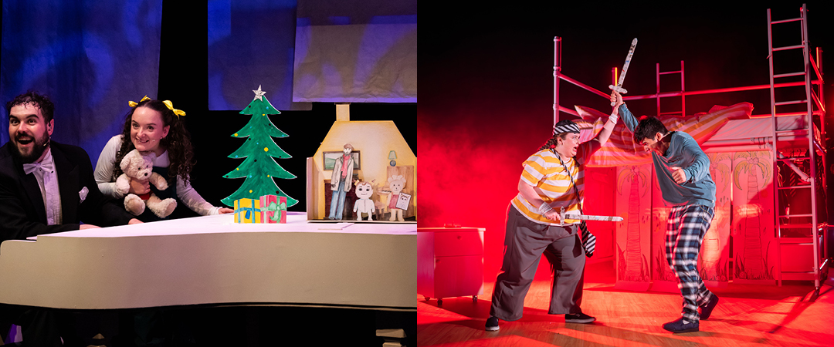

Left: Special Delivery © Cumbernauld Theatre, 2024. Photo by Sally Jubb.  
Right: Treasure Island © Scottish Theatre Producers, 2024. Photo by Mihaela Bodlovic.

Cumbernauld Theatre Trust is celebrating the recognition of two of its recent productions, *Special Delivery* and *Treasure Island*, which have been nominated for this year’s prestigious Critics’ Awards for Theatre in Scotland (CATS).

The nominations shine a spotlight on the organisation’s bold artistic vision and its unique collaborative commissioning model; a model now under threat following Creative Scotland’s decision to withdraw core funding.

Nominated for Best Production for Children and Young People, *Special Delivery* was co-produced with Visible Fictions and Scottish Opera and staged in Cumbernauld’s intimate Studio Theatre in winter 2024. The show blended live music, original songs, storytelling and playful animation to delight audiences aged 3–7.

Also nominated is *Treasure Island*, a reimagined version of the Stevenson classic by Ross MacKay, which premiered on Cumbernauld’s Theatre’s main stage in 2022 and returned in 2024, during a successful Scottish tour.

Cumbernauld Theatre’s distinctive approach to making work centres around an authentic process of collaboration between artists, community and staff. The organisation’s commissioning and producing process gave rise to new ways of working and established exciting new artistic collaborations. It’s a model that promoted creativity, removed barriers to access key roles in theatre, and sought to open the commissioning process to engage the community and ultimately aimed to make theatre production more equitable.

However, in January 2025, Creative Scotland removed Cumbernauld Theatre from its Multi-Year Funding portfolio, a decision that effectively ends the organisation’s ability to commission and produce original work. Without core funding, the model that made these CATS-nominated productions possible can no longer be sustained.

“These nominations demonstrate what is possible when we invest in creative people and support long-term artistic development,” said Sarah Price, Chief Executive of Cumbernauld Theatre. “We’ve shown that a new, inclusive way of making theatre can deliver work of exceptional quality and community relevance. Yet, without core funding, we are no longer in a position to continue producing. That is the true cost of this decision.”

It is one of the few remaining producing theatres in a community facing deep economic inequality, and its loss will leave a significant cultural gap in North Lanarkshire and across Scotland. “This isn’t just about awards,” Price continued. “It’s about a model that worked - for artists, for audiences, for our town. That model has been recognised on a national stage, even as it is being dismantled by a funding decision that makes no sense in terms of either artistic merit or community impact.”

Cumbernauld Theatre Trust continues to advocate for a reassessment of Creative Scotland’s decision and a renewed commitment to support place-based arts infrastructure.

For more information about Cumbernauld Theatre’s productions and commissioning model, visit: [lanternhousearts.org/about-us/our-work](https://lanternhousearts.org/about-us/our-work)

**ENDS/**

-----------

**A selection of press images can be found** [**here**](https://drive.google.com/drive/folders/1Swz0UE84ThhqK4rVw_6gYbFTGfSP0fkp?usp=share_link)**.**

**For more information, contact:**

**Rachel Murphy, Marketing & Communications Manager, Cumbernauld Theatre:**

[rmurphy@cumbernauldtheatre.co.uk](mailto:rmurphy@cumbernauldtheatre.co.uk?subject=The%20Events,%20Cumbernauld%20Theatre) / 01236 807 494

**Notes for editors**

**Cumbernauld Theatre Trust**  
Cumbernauld Theatre Trust is a performing arts charity that produces and presents professional theatre, music, dance and comedy experiences for a community of 50,000 Cumbernauld residents and 100,000 North Lanarkshire population. Established in 1963, Cumbernauld Theatre is the only professional independent arts organisation in Cumbernauld and North Lanarkshire and serves a vital social, cultural and economic purpose in a community that is economically disadvantaged, with widespread material poverty and deprivation, low academic attainment and poor-quality built environment.

As an established, professional producing theatre, we are both community-led and community conscious with activity that responds to the needs of the local community, yet we deliver outputs that achieve national and international recognition.

We aim for our work to have relevance and resonate with our audiences and participants to achieve deep and lasting impact and change. This work is informed by place, by the opportunities our new arts centre provides and by a desire to deliver affordable access to culture for everyone at all life-stages. Cumbernauld Theatre Trust is a key part of the infrastructure of Scotland’s performing arts and is a Regularly Funded Organisation (RFO) within the Creative Scotland portfolio. We receive investment in support of our work from a range of sources including Creative Scotland and North Lanarkshire Council, Weston Culture Fund and Scottish Government’s Empowering Communities Programme – Investing in Communities Fund.

Cumbernauld Theatre Trust is also supported by Screen Scotland, Equity Charitable Trust, Foyle Foundation, The Levenseat Trust, The Trades House of Glasgow Commonweal Fund, Land Trust, Robert Barr’s Charitable Trust, Hugh Fraser Foundation, The Robertson Trust and Patersons Quarries, our Friends, and donors.

Lanternhouse is a privately-owned property built through Scottish Futures Trust (SFT) investment jointly operated by North Lanarkshire Council (NLC) and Cumbernauld Theatre Trust. The construction of Lanternhouse was financed via the SFT-managed hub community infrastructure programme for local authorities in support of the Scottish Government’s National Infrastructure Mission to drive inclusive economic growth and build resilient places. For more information visit <https://www.scottishfuturestrust.org.uk/>.

<http://www.lanternhousearts.org/> | [info@lanternhousearts.org](mailto:%E2%80%AFinfo@lanternhousearts.org)

Cumbernauld Theatre Trust Ltd is a Registered Company limited by guarantee No. SC066490, Scottish Charity OSCR Registered No. SC005050. Registered Office: Cumbernauld Theatre Trust, Lanternhouse, South Kildrum Ring Road, Cumbernauld, North Lanarkshire, G67 2UF

Lanternhouse is a registered trademark (UK00003494622) owned by Cumbernauld Theatre Trust Ltd.