Connolly’s Cumbernauld Flourish: a new community play celebrating Billy Connolly’s life and links to Cumbernauld
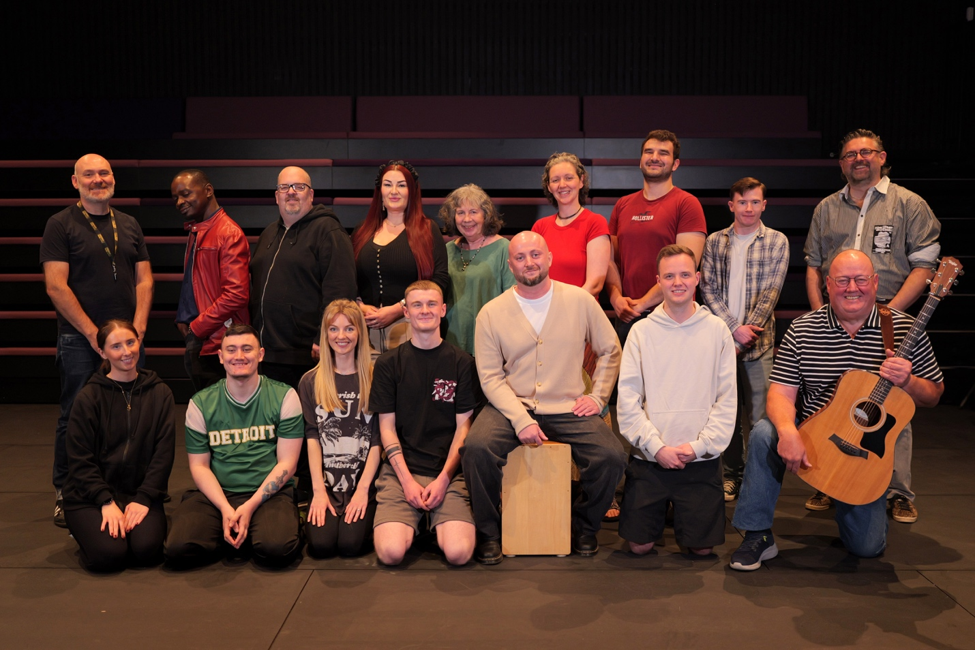
COMMUNITY CAST OF CONNOLLY’S CUMBERNAULD FLOURISH. PHOTO CREDIT: SARTORIAL PICTURES
Images can be found here.

- A brand-new production from Cumbernauld People’s Theatre Company
- Celebrating Billy Connolly’s life from humble beginnings to his debut at Cumbernauld Theatre in 1972
- Written and directed by Lawrence Crawford
- Featuring stories from the Cumbernauld community alongside a live band, music, comedy and dance

Cumbernauld People’s Theatre Company brings a new production to the stage this autumn with Connolly’s Cumbernauld Flourish, a community celebration of Billy Connolly’s life and the legendary comedian’s connection to Cumbernauld.
Few people know that Billy Connolly made his theatrical debut at Cumbernauld Theatre in 1972 with Connolly’s Glasgow Flourish. More than fifty years later, this new play revisits that landmark moment, blending Connolly’s early life and music with personal memories and anecdotes from the local community to create a heartfelt tribute to one of Scotland’s most beloved figures. The play follows Billy’s journey from humble beginnings, celebrating the music and stories that connect him to Cumbernauld, and concludes in 1972 with his first appearance at Cumbernauld Theatre’s former home, the Cottage Theatre.
The play follows Billy’s journey from humble beginnings, celebrating the music and stories that connect him to Cumbernauld, and concludes in 1972 with his first appearance at Cumbernauld Theatre’s former home, the Cottage Theatre. By focusing on his early years, the show shines a light on a part of his story that has rarely been told, showing the role Cumbernauld played in shaping the Big Yin we know today.
Declan Porter (cast member) said: “I’ve enjoyed learning all the stories about Billy and seeing all the photos that we’ll use in the show… I’ve learned that acting is something anyone can do and that you should put yourself out there even if others don’t believe in you.”
Johanne Miller (cast member) added: “The music, the craic and the dancing have been the best part. I’ve also learned how difficult it is to be funny while being scripted. If you love music, laughter and learning about the life of the Big Yin, please come join us!”
Written and directed by Lawrence Crawford, Connolly’s Cumbernauld Flourish continues the company’s tradition of telling local stories for local people, following previous productions Night in the Nauld and The Cottage that Became a Theatre.
Lawrence Crawford, writer and director, said: “The story came out of the research I was doing for The Cottage That Became a Theatre, when I discovered Billy Connolly’s close association with Cumbernauld and the Cottage Theatre. The play covers his early life, celebrates him as a musician, and takes us up to the point where he moved from being a folk musician into being a stand-up comedian. What makes this show unique is that it’s telling a part of Billy’s story that hasn’t really been told before, while also including the voices of people from Cumbernauld who remember him and his time here.”
Connolly’s Cumbernauld Flourish will run at Lanternhouse Main Auditorium from Fri 3 October to Sat 4 October.
ENDS ----------------------------

Images and media can be found here.
For more information, contact:
Rachel Murphy, Communications & Communication Manager, Cumbernauld Theatre:
rmurphy@cumbernauldtheatre.co.uk / 01236 732887
Production info
Connolly’s Cumbernauld Flourish
Written and Directed by Lawrence Crawford
Presented by Cumbernauld People’s Theatre Company

Previous work includes Night in the Nauld and The Cottage that Became a Theatre.

Listings info

Friday 3 October – Saturday 4 October at 7.30pm.
Ticket prices: £10 - £14

For tickets and full listings information call the box office on 01236 732887 or visit https://lanternhousearts.org

Biographies
Lawrence Crawford
Lawrence trained at RADA and the RSAMD.
Initially working as an actor Lawrence made the transition to writing and directing after being frustrated at the roles he was reading for as a Scottish actor. He set up Tron Studio and Arches Actors’s lab. He has specialised in adult drama although for many years he directed Falkirk youth theatre’s yearly panto. He has worked for most theatre companies in Scotland including NTS, Borderline theatre. Tron Theatre, Royal Lyceum and of late has developed an association with Cumbernauld theatre. He is also a musician in his spare time and releases tracks as Arkle. A father of two he grew up in Milton of Campsie and currently lives in Hamilton.
Cumbernauld Theatre Trust
Cumbernauld Theatre Trust is a performing arts charity that produces and presents professional theatre, music, dance and comedy experiences for a community of 50,000 Cumbernauld residents and 100,000 North Lanarkshire population. Established in 1963, Cumbernauld Theatre is the only professional independent arts organisation in Cumbernauld and North Lanarkshire and serves a vital social, cultural and economic purpose in its community.
Lanternhouse is a privately-owned property built through Scottish Futures Trust (SFT) investment jointly operated by North Lanarkshire Council (NLC) and Cumbernauld Theatre Trust. The construction of Lanternhouse was financed via the SFT-managed hub community infrastructure programme for local authorities in support of the Scottish Government’s National Infrastructure Mission to drive inclusive economic growth and build resilient places.
http://www.lanternhousearts.org/ | info@lanternhousearts.org
Cumbernauld Theatre Trust Ltd is a Registered Company limited by guarantee No. SC066490, Scottish Charity OSCR Registered No. SC005050. Registered Office: Cumbernauld Theatre Trust, Lanternhouse, South Kildrum Ring Road, Cumbernauld, North Lanarkshire, G67 2UF
Lanternhouse is a registered trademark (UK00003494622) owned by Cumbernauld Theatre Trust Ltd.

People’s Theatre Comapny
Cumbernauld People’s Theatre Company is a community theatre project that offers adults aged 18+ who are interested in theatre and the performing arts the opportunity to work collaboratively with artists and theatre practitioners to develop socially engaged theatre projects at Cumbernauld Theatre.
PROJECT AIMS
- To create an inclusive, socially engaged community-based theatre project that allows participants to develop skills in theatre, acting, writing, film, and the performing arts
- To develop participants self-confidence and self-esteem
- To encourage and unlock creativity and creative potential
- To develop theatre and performing arts skills
- To promote community connectivity, and develop community empowerment
- To promote friendships and social connectivity
- To develop sense of place belonging
- To offer participants the opportunity to present, share, and showcase work at Cumbernauld Theatre
- To create an inclusive, socially engaged community-based theatre project that allows participants to develop skills in theatre, acting, writing, film, and the performing arts
Cumbernauld Theatre People’s Theatre Company works collaboratively with participants through weekly workshop and rehearsal programme. Working in partnership with artists and project with the project theatre artists the group develop, and devise theatre socially engaged theatre, film and writing projects with our community to develop Community and Individual Empowerment, Artistic Skills Development, Cultural Enrichment, Community Cohesion, Sustainable Practises, and Climate awareness.

