First Look at Cumbernauld Theatre’s magical festive stage shows
- A new Cumbernauld-set Pinocchio, written by Gary McNair, is running at the Lanternhouse Main Auditorium until 29 December.
- Cumbernauld Theatre Company is also collaborating with Visible Fictions and Scottish Opera for Special Delivery will be an enchanting musical journey filled with wonder for little ones aged 3 – 7 with music by Karen MacIver
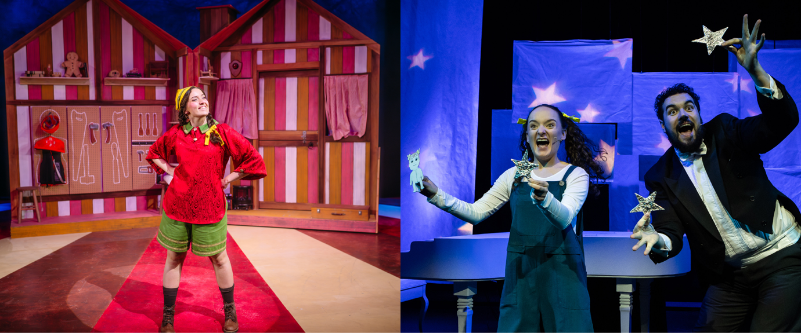
Left image: Julia Murray in Pinocchio – pic by Mihaela Bodlovic
Right image: Jessica Donnelly and Craig Hunter in Special Delivery – pic by Sally Jubb

Production images available HERE
Cumbernauld audiences are in for a festive treat this December, with the premiere of two special stage shows set to delight families in the run-up to Christmas.
The Main Stage at Lanternhouse has transformed into a Timbernauld as Pinocchio, a raucous new take written by Gary McNair, is now open.
All Pinocchio has ever wanted is to be a real boy. But hold on…if he wants things, surely that means he has thoughts and feelings. And if he has thoughts and feelings, then doesn’t that mean he has a brain and a heart? And if he has all that, doesn’t that make him a real boy already?
Pinocchio is written by Gary McNair, led by Director Laila Noble, with music by Brian James O’Sullivan and design by Fraser Lappin, and is brought to life by theatre talent Julia Murray, Cole Stewart, Stephanie MacGaraidh and Caitlin Forbes.
Laila Noble, Director of Pinocchio said: ‘Pinocchio is wild, wacky, and full of silly fun—my favourite things—but it also has a really beautiful moral heart and soul. This version embraces what it means to be out in the world, facing challenges and barriers, while finding confidence and adventure. Gepetta has a really beautiful moral arc in the story... an important discussion for kids and for families about how we protect ourselves and how we make sure that we're having adventure and fun and seizing the day. And there's such a wonderful creative team and cast bringing this story to life.’
Meanwhile, Special Delivery, an enchanting children’s show co-produced with Visible Fictions and Scottish Opera, is now open in the Studio Theatre.
Not all good things come in neatly wrapped packages. Sometimes they arrive as you least expect them… with a thud, down your chimney! Join Santa on his busiest night of the year, Christmas Eve. Travelling around the world and squeezing down chimneys to deliver presents is a tough job, but this time it’s made even more difficult when he is joined by a tiny mischievous hitchhiker, Eve, who is looking for a way back home.
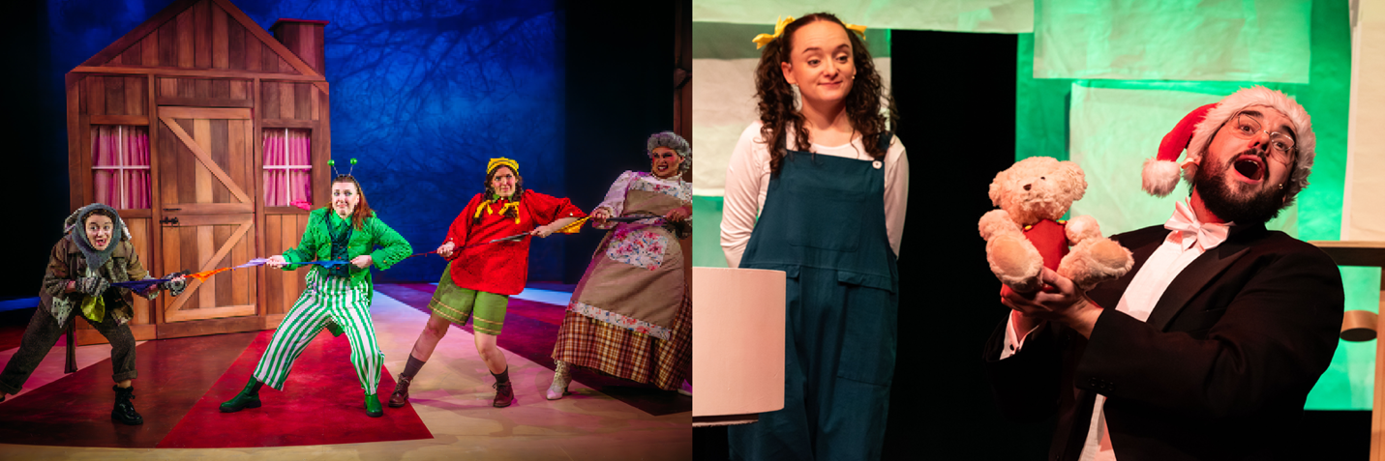
Left image: Caitlin Forbes, Stephanie Murray, Julia Murray and Cole Stewart in Pinocchio – pic by Mihaela Bodlovic
Right image: Craig Hunter and Jessica Donnelly in Special Delivery – pic by Sally Jubb
Special Delivery was composed by Karen MacIver with words by Clive King. The cast comprises two talented Royal Conservatoire of Scotland graduates and is led by director Dougie Irvine of Visible Fictions.
Dougie Irvine, Director of Special Delivery said: ‘Special Delivery tells the story of a little toddler who gets swept up the chimney with her drawing for Santa and unexpectedly lands in Santa's workshop… The production combines live piano, enchanting music, and animation to create a magical tale of adventure, friendship, and the true spirit of Christmas that will captivate audiences of all ages.’
Pinocchio will run at Lanternhouse Main Auditorium until Sun 29 December, with an opening press performance on Thursday 28 November at 7pm. Special Delivery will run at Lanternhouse Studio Theatre until Saturday 29 December, with an opening press performance on Friday 6 December at 10.00am. Run time 40 mins. No Interval.
ENDS -
-----------
IMAGES
Production images and captions for Pinocchio and Special Delivery can be found HERE
For more information, contact:
Rachel Murphy, Marketing & Communications Manager, Cumbernauld Theatre: rmurphy@cumbernauldtheatre.co.uk / 01236 807 494
Production info

Pinocchio
Written by Gary McNair, Directed by Laila Noble, Music by Brian James O’Sullivan, Design by Fraser Lappin
A Cumbernauld Theatre Company Production

Cast:
Julia Murray – Pinocchio
Cole Stewart – Gepetta
Stephanie MacGaraidh – Hingwy, Salesman / Stomboli / Whale
Caitlin Forbes – Mozart / Honest Sean / 90’s Guy / Passerby / Clicky

Special Delivery
Music by Karen MacIver, Written by Clive King, Directed by Dougie Irvine
Presented by Cumbernauld Theatre Company, Visible Fictions and Scottish Opera

Cast:
Craig Hunter
Jessica Donnelly

Listings info

Pinocchio:
Open now until Sunday 29 December (Various Times)

Press Performance on Thu 5 December at 7pm
Relaxed Performances on Wed 11 December at 2.30pm and Sun 15 December at 1.30pm
Audio Described Performance on Wed 18 December at 7pm
Signed Performance on Thu 19 December at 7pm
Ticket prices: £14 - £25

For tickets and full listings information call the box office on 01236 732887 or visit https://lanternhousearts.org

Special Delivery:
Open now until Saturday 29 December (Various Times)

Preview performances on Until Thu 5 December, 10.00am and 1.00pm
Press Performance on Fri 6 December, 1.00pm
Audio Described Performance on Sat 14 December, 1.00pm
BSL Signed Performances on Sat 21 December – Sun 22 December, 13.30am, 1.00pm
Relaxed Performance on Sat 21 December – Sun 22 December, 13.30am, 1.00pm
Ticket prices: £6

For tickets and full listings information call the box office on 01236 732887 or visit https://lanternhousearts.org

Notes for editors
Cumbernauld Theatre Trust
Cumbernauld Theatre Trust is a performing arts charity that produces and presents professional theatre, music, dance and comedy experiences for a community of 50,000 Cumbernauld residents and 100,000 North Lanarkshire population. Established in 1963, Cumbernauld Theatre is the only professional independent arts organisation in Cumbernauld and North Lanarkshire and serves a vital social, cultural and economic purpose in a community that is economically disadvantaged, with widespread material poverty and deprivation, low academic attainment and poor-quality built environment.
As an established, professional producing theatre, we are both community-led and community conscious with activity that responds to the needs of the local community, yet we deliver outputs that achieve national and international recognition.
We aim for our work to have relevance and resonate with our audiences and participants to achieve deep and lasting impact and change. This work is informed by place, by the opportunities our new arts centre provides and by a desire to deliver affordable access to culture for everyone at all life-stages. Cumbernauld Theatre Trust is a key part of the infrastructure of Scotland’s performing arts and is a Regularly Funded Organisation (RFO) within the Creative Scotland portfolio. We receive investment in support of our work from a range of sources including Creative Scotland and North Lanarkshire Council, Weston Culture Fund and Scottish Government’s Empowering Communities Programme – Investing in Communities Fund.
Cumbernauld Theatre Trust is also supported by Screen Scotland, Equity Charitable Trust, Foyle Foundation, The Levenseat Trust, The Trades House of Glasgow Commonweal Fund, Land Trust, Robert Barr’s Charitable Trust, Hugh Fraser Foundation, The Robertson Trust and Patersons Quarries, our Friends, and donors.
Lanternhouse is a privately-owned property built through Scottish Futures Trust (SFT) investment jointly operated by North Lanarkshire Council (NLC) and Cumbernauld Theatre Trust. The construction of Lanternhouse was financed via the SFT-managed hub community infrastructure programme for local authorities in support of the Scottish Government’s National Infrastructure Mission to drive inclusive economic growth and build resilient places. For more information visit https://www.scottishfuturestrust.org.uk/.
http://www.lanternhousearts.org/ | info@lanternhousearts.org
Cumbernauld Theatre Trust Ltd is a Registered Company limited by guarantee No. SC066490, Scottish Charity OSCR Registered No. SC005050. Registered Office: Cumbernauld Theatre Trust, Lanternhouse, South Kildrum Ring Road, Cumbernauld, North Lanarkshire, G67 2UF
Lanternhouse is a registered trademark (UK00003494622) owned by Cumbernauld Theatre Trust Ltd.

