PRESS RELEASE – For immediate use, Tuesday 30 September 2025

Less than Three Months to Save Cumbernauld Theatre
As the new town of Cumbernauld gets set to mark 70 years since its founding on 9 December, the creative organisation which has been the heart of its community for 60 years has a December deadline for survival.
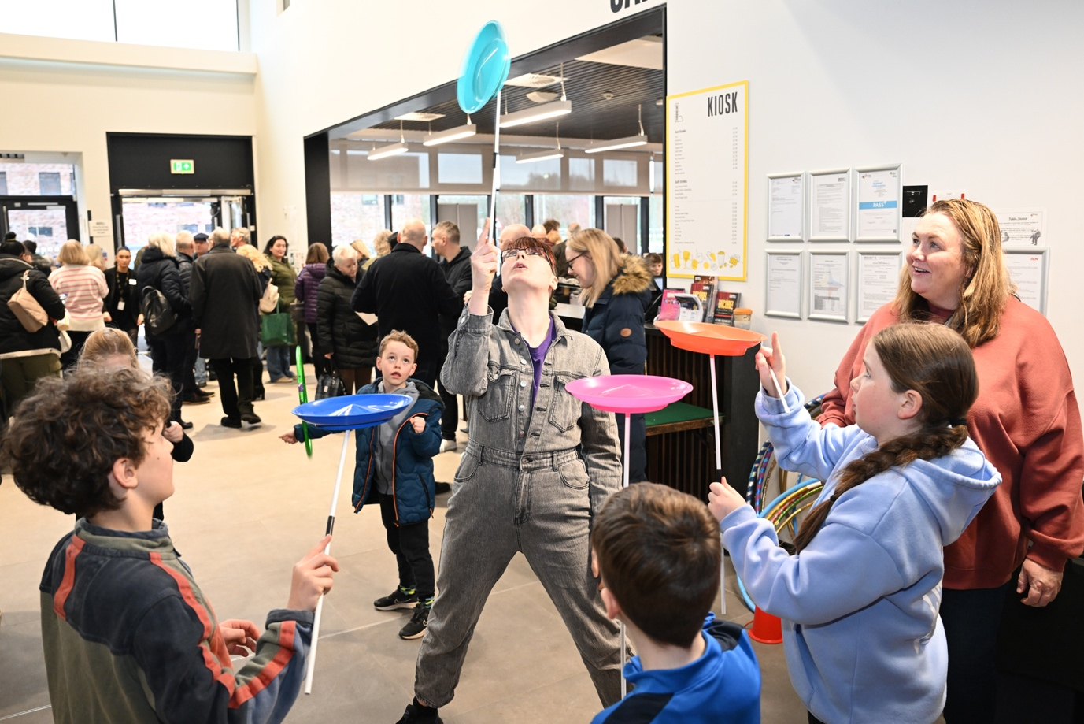
Following Creative Scotland’s decision not to renew Cumbernauld Theatre’s Multi Year Funding in 2025 the organisation has undergone significant change, challenging all aspects of its operation to put forward a fresh plan for its future.
Patricia Stead, Interim CEO of Cumbernauld Theatre said: “We have worked hard with partners and consultants to develop a new model for the theatre which truly puts participation at the heart of everything we do. It is a sustainable plan shaped by our audiences and communities, shaped by the needs and priorities of local people and shaped to ensure that our young people and communities have the opportunity to thrive.
“We also want to continue, as the only theatre and cinema in the area, to be able to bring the best stage and film experiences to our local audiences in a place where they can come comfortably, affordably and in a sense of regular togetherness and community. To do this we need to survive until we can apply again for regular funding.”
Following months of engaged, proactive talks with the organisation’s key funders and partners, Cumbernauld Theatre is saddened to share that Creative Scotland has confirmed it will not extend its transition funding into 2026. Without further support the theatre will be forced to close during 2026 and return the building to North Lanarkshire Council. To be allowed to continue as a going concern, Cumbernauld Theatre needs to secure £300,000 by mid December this year.
Laura Johnstone, Front of House manager, said: “Cumbernauld Theatre has served our community for over 60 years. This is where our young people come to gain confidence, our elder generations to dance, our emerging musicians to cut their teeth and our theatre and cinema fans to access some of the world’s best on their doorstep. These local people coming together in our space are like family, we know each other and we support each other.
“Next year marks Cumbernauld's 70th anniversary as a New Town. We want to be at the heart of that milestone moment with a packed programme of activity which brings people together in creativity, cementing community and connection. But instead, the reality may be that the 70th year of this town may see the closure of this cultural asset for good.”
Iain Mackenzie, a Trustee of Cumbernauld Theatre and long-term resident, said: “Each year we stage 150 live performances, deliver more than 400 community classes and welcome 50,000 people through our doors. We are a vital resource for the people of Cumbernauld boosting the town’s sense of identity, of pride and of belonging. What we do is at the heart of Cumbernauld’s collective success.”
Patricia Stead concluded: “The people of Cumbernauld deserve better. One unsuccessful application should not mean the loss of the area’s only theatre and cinema, nearly 40 local jobs, and the creative opportunities that have supported generations for 60 years.
“We very much welcome the proactive conversations we are engaged in with Angus Robertson and we urge him and his colleagues at Scottish Government to work with the leadership of Creative Scotland and North Lanarkshire Council to help us find a solution in time to save everything that has been built over six decades and is so essential to this town’s future.”
If you’d like to help please consider signing the petition, sharing your memories of Cumbernauld Theatre and what it means to you, or donating to the campaign.
Find out more here.
/ENDS
Media contact: Susie Gray, Premier - susie.gray@premiercomms.com 07834 073795
Free to use images HERE

History of Cumbernauld Theatre

