FRIDAY 12 DECEMBER 2025
Cumbernauld Theatre Trust secures strategic investment from Scottish Government, enabling it to plan a future to benefit many residents and artists.
- Scottish Government awards £150,000 grant over 2026/27, and a potential further £150,000 in 2027/28, the key factor in sustaining Cumbernauld Theatre Trust for the future.
- Cumbernauld Theatre also welcomes £99,557 support from Creative Scotland towards a major, new initiative to bring old and new communities of Cumbernauld together in celebration of the town's 70th anniversary.
- Theatre expresses huge thanks to its communities and peers for their support of this campaign.
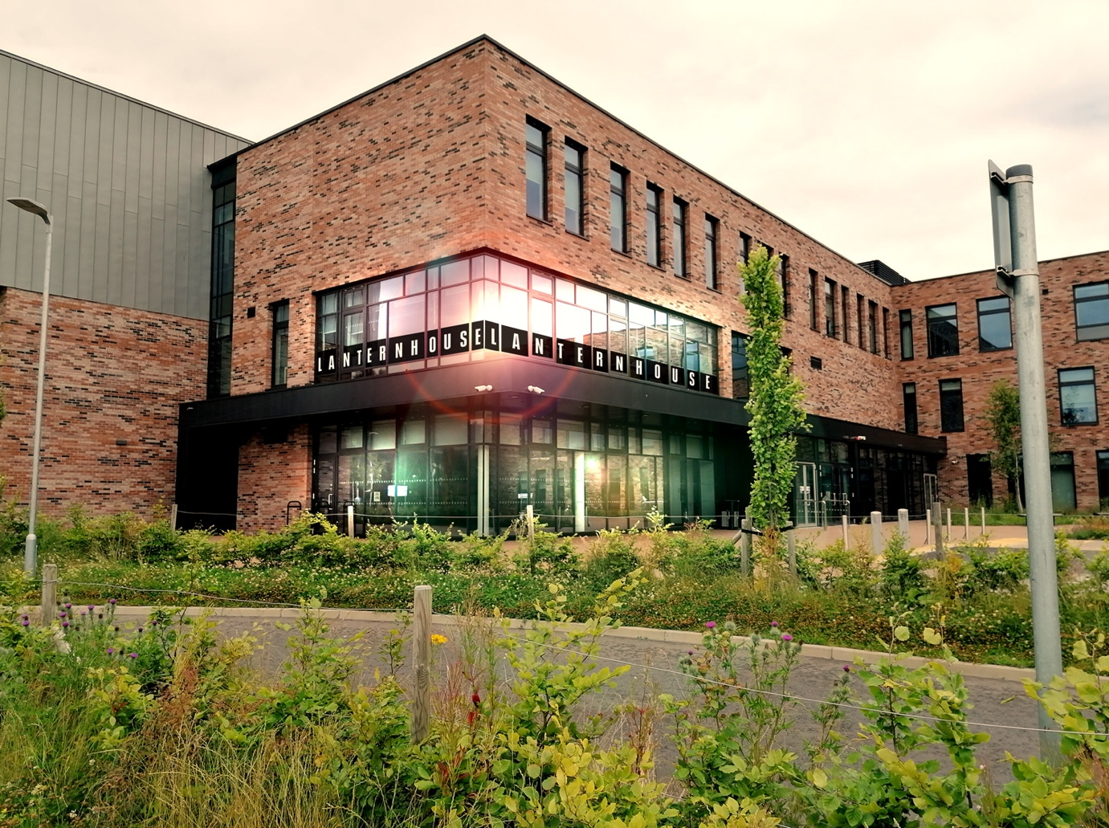
In the week which marks 70 years since the designation of Cumbernauld as a New Town, a significant new funding award from the Scottish Government has been announced, which alongside the approval of a project funding application to Creative Scotland and donations from individuals and local businesses will enable the organisation to plan for a bright future.
After constructive discussions over a number of months between the theatre and the Cabinet Secretary for Constitution, External Affairs and Culture Angus Robertson and his team, today, Cumbernauld Theatre and Scottish Government are able to announce £150,000 grant funding from the Government in 2026/27 and a potential further award of £150,000 in 2027/28. This marks a significant commitment which goes a long way to supporting the theatre trust to secure its future.
The theatre’s campaign was unwaveringly supported throughout by Cumbernauld & Kilsyth MSP Jamie Hepburn, and garnered strong cross party support, particularly from Katrina Murray MP, Mark Griffin MSP, Gillian MacKay MSP and Meghan Gallacher MSP, as well as many local councillors.
The pledge came in the same week that Creative Scotland agreed to give Cumbernauld Theatre Trust £99,557 in support of a programme of community engagement and work celebrating the town’s anniversary over the course of 2026.
The outpouring of support from the people of Cumbernauld and industry peers across the country has significantly contributed to the decision to invest. A generous total of just over £40,000 has now been raised by the theatre’s campaign, alongside the sharing of passionate stories and testimonies which have clearly demonstrated the theatre’s importance and impact on the local population and on the sector.
Patricia Stead, Interim Chief Executive of Cumbernauld Theatre Trust said: “We are incredibly grateful to the Scottish Government for its strategic investment in the future of this important cultural organisation. Their pledge of £150,000 in 2026/27 allows the Trust time to plan for a long-term sustainable future, while continuing to deliver its valuable work for residents in an area of Scotland which is under-served in terms of cultural and community opportunities. We thank both Angus Robertson and his team for making this happen, our MSP Jamie Hepburn for his unwavering support, and the politicians and councillors across all parties who have supported us.
“We are sure that without the outpouring of support – both financial and through emotional stories of connection and importance – from the community that surrounds us locally and in our sector, that we would not be in this position and we owe a huge debt of thanks to all those who got involved in this campaign.
“Although we have made huge steps today in protecting the future of Cumbernauld Theatre, we do still have almost £10,000 to raise towards our target of £50,000 and the need to fundraise will continue into the future. We hope that the confidence that this Government investment gives will enable those who have been hesitant, to join in supporting us over the next couple of years through donations, attending our ongoing fundraisers and buying tickets to our theatre and cinema performances and becoming Friends of Cumbernauld Theatre Trust.
“As you can imagine this has been an incredibly stressful time for the team at Cumbernauld Theatre who despite not knowing if their jobs would exist come the Spring, have continued to greet our audiences warmly, work tirelessly and ensure that the show went on regardless. We thank them greatly for their passion, their belief and their efforts.
“We look forward to deepening our partnership with North Lanarkshire Council in order to maximise the benefits of Lanternhouse as a cultural hub for the people of Cumbernauld and beyond. And we thank Creative Scotland for this important sign of support and look forward to building a new relationship with them over the coming years.”
Culture Secretary Angus Robertson said: “The Cumbernauld Theatre is an important cultural asset for North Lanarkshire and the wider culture sector in Scotland.
“As a result of its failure to secure Multi-Year Funding, the Trust faced a critical funding gap for 2026-27, which would have required the Trust to consult on redundancies.
“Given the Theatre’s significance to the community and in order to protect the sector-specific skills it provides employment opportunities for, the Scottish Government has agreed to support the Trust with £150,000 in grant funding over 2026-27, and a potential further £150,000 in 2027-28 – subject to the Trust demonstrating its sustainability issues are being resolved. This funding should enable the Trust to move beyond a challenging period and take the necessary steps to secure Cumbernauld Theatre’s future.”
Cumbernauld Theatre’s Christmas Show, BALTIC has been playing to enthusiastic audiences and continues until Christmas Eve on 24 December.
There are also fundraiser nights taking place across January to March including the Rock Choir for Cumbernauld on 17 January, Cumbernauld Folk Club Fundraiser on 22 January, Burns by Candlelight on 1 February, The Football Show from the creators of Only an Excuse on 5 February, Darren McGarvey's Trauma Industrial Context: The Live Show on 26 March and others to be announced. More information here - https://lanternhousearts.org/recurring-show/fundraising-events/
/ENDS
Media contact: Susie Gray, susie.gray@premiercomms.com 07834 073795
Photos of Cumbernauld Theatre’s current show BALTIC running until 24 December.

