PRESS RELEASE | 6 March 2026
Raw Material and Cumbernauld Theatre announce Forbes Masson’s Aladdie for Christmas 2026
- Forbes Masson’s Aladdie will be a brilliantly bubbly, fantastically funny, bursting with banter Scottish panto with a spin
- A co-production from Raw Material and Cumbernauld Theatre, directed by Gordon Dougall
- At Cumbernauld Theatre from Thursday 26 November to Thursday 24 December 2026
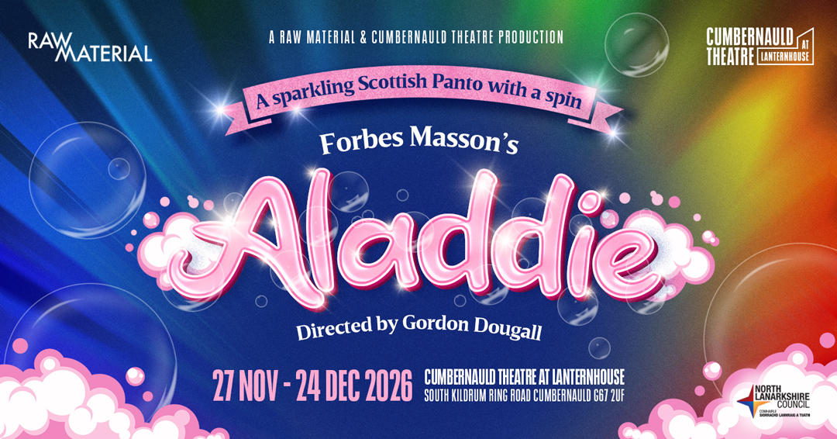

Raw Material and Cumbernauld Theatre will work together this Christmas to co-produce Aladdie, written by acclaimed actor and playwright Forbes Masson and directed by Gordon Dougall.
Originally created for the Tron Theatre, where it was praised for its sharp writing and original music, Aladdie will be newly reworked for Cumbernauld audiences, with Masson and Dougall collaborating once again.
Forbes Masson said: ‘Pantomime is often a child’s first experience of live theatre, so it has to be alive. It can’t be lazy. It has to have a proper story at its heart. If you get that right, the comedy can go anywhere. Aladdie is about a twenty-first century Scottish antihero finding his confidence in a world that feels stacked against him. Bringing it to Cumbernauld and working with Gordon again feels like exactly the right kind of creative mischief.’
Aladdie is a boy who’s so poor he hasnae even got a name. He’s just a laddie. He keeps cheery thanks to his best pal Peely Wally, a ginormous singing pigeon, and together they work at the market in the magical town of Bubblenauld, a place not unlike Cumbernauld, only somewhat sillier, surprisingly soapier and supremely singalongsongier.
Bubblenauld is quite literally bubbly, with thousands of soap bubbles drifting from the old leaky washing machines in the legendary laundrette Manky Washing, run by Aladdie’s mum Widow Manky. But hard times have left her struggling to keep the place going.
Enter nasty Uncle Rab Anazer, the richest and meanest creature in all of Bubblenauld. He wants to con Widow Manky out of her laundrette, knock it down and make himself even richer while everyone else grows more skint and miserable.
When Aladdie receives a miraculous visit from Magic Auntie Jeanie and her enchanted wishing powder, he finally has a chance to fight back, save the laundrette and maybe even win the heart of the gorgeous Lorna Sausage. But Rab Anazer has plenty of dastardly tricks up his sleeves and even magic might not be enough to stop him.
Raw Material’s Executive Producers, Gillian Garrity & Margaret-Anne O’Donnell said: ‘We worked as ushers at the Tron Theatre back in the day when Forbes and Gordon were starring in the Tron Pantos so it’s a thrill to now be working with them to redevelop Aladdie for new audiences and we are doubly excited to be co-producing with the team at Cumbernauld Theatre, one of Scotland’s most vibrant and welcoming venues.’
Cumbernauld Theatre Interim CEO, Patricia Stead added: ‘Our fantastic panto audiences in 2025 have inspired us to transform Lanternhouse into pantoland once again in 2026. We’re excited to be co-producing Aladdie with Raw Material, whose track record in producing bold Scottish theatre speaks for itself, and to be working with the panto dream team of Forbes Masson and Gordon Dougall. There will be singing, dancing, magical storytelling, audience participation and plenty of laughter as Aladdie, Widow Manky and the gang open their laundrette in Cumbernauld.’
Further creative and cast credits to be announced.
On sale dates are as follows:
Presale to Friends of Cumbernauld Theatre on Friday 6 March
Public on sale on Tuesday 10 March

-----------

Images and assets can be found here.
For more information, contact:
Rachel Murphy, Marketing & Communication Manager, Cumbernauld Theatre:
rmurphy@cumbernauldtheatre.co.uk / 01236 732887
Production info
Forbes Masson’s
Aladdie
Directed by Gordon Dougall

Script by Forbes Masson
Songs by Forbes Masson & Gordon Dougall
Designed by Kenny Miller
Costume Design by Jennie Lööf

Listings info

Thursday 26 November – Thursday 24 December (Various Times)

Preview performances on
Thu 26 November (7pm)
Fri 27 November (10:30am & 7pm)

Press Performance on Tue 1 December, 7pm
BSL Signed Performance on Sat 5 December, 2pm
Relaxed Performances on Thu 3 December (10:30am) & Sat 12 December (2pm)
Ticket prices: £12 - £26
For tickets and full listings information call the box office on 01236 732887 or visit https://lanternhousearts.org
Biographies
Forbes Masson - Writer
Forbes Masson is best known for co creating and starring in the cult BBC comedy The High Life with Alan Cumming, which now returns as a new stage musical touring Scotland in 2026 with the National Theatre of Scotland.
One of Scotland’s most versatile performers, he is an Associate Artist of the Royal Shakespeare Company and the National Theatre of Scotland. His theatre credits include Much Ado About Nothing, The Tempest, Hamlet, Macbeth and Gary McNair’s Jekyll and Hyde, while television appearances range from The Crown and Shetland to EastEnders and The High Life.
As a writer, Forbes has created work for stage and screen for over three decades. His writing includes Victor and Barry, which toured from the Edinburgh Festival to the Donmar Warehouse and Sydney Opera House, the stage musicals Stiff, Mince and Pants, and a series of acclaimed pantomimes for the Tron Theatre including Jack and the Beanstalk, Cinderella, Aladdie and Weans in the Wood, helping to redefine the modern Scottish panto.
Gordon Dougall – Director
Gordon Dougall is a multi-award winning director, composer and musical director with over five decades of experience in theatre and live performance. He directs across drama and large-scale musical productions and is widely recognised for his work in shaping contemporary Scottish theatre.
He was in house composer and musical director at the Tron Theatre during Sir Michael Boyd’s tenure and later became Director of the Tron pantomimes, directing productions including Cinderella, Aladdie and Weans in the Wood. He has also worked extensively with Dundee Rep, the King’s Theatre Glasgow, Manchester Royal Exchange, the Belgrade Theatre Coventry and The Hydro Glasgow.
Gordon has composed, arranged and supervised music for productions across the UK and internationally, including work with the National Theatre of Romania and projects in Hungary and Tanzania. His collaborations with Forbes Masson include the musicals Stiff! and Mince, and numerous pantomimes, and he continues to work as a composer and musical director on new stage projects.
He is Artistic Director of Limelight Music and remains an active force in Scottish theatre as a director and music collaborator.
Notes for editors
Cumbernauld Theatre Trust
Vision: To be the cultural heart of Cumbernauld and North Lanarkshire, engaging our communities and strengthening Scottish performing arts.
Mission: We bring people together through performances on stage and screen, provide opportunities to create and take part in the arts and help develop Scotland’s performing arts professionals.
Cumbernauld Theatre is a regional performing arts venue serving Cumbernauld’s population of 55,000+ and the surrounding communities of North Lanarkshire and the northern corridor, as well as neighbouring areas including Falkirk. The organisation presents a programme of diverse, professional performing arts and cinema events, opportunities for the local community to take part in creative activities, development support for Scotland’s creative performing arts sector and, in partnership with North Lanarkshire Council, provides an excellent venue for local community performing arts organisations to present their own work. With a 60-year history of producing our own theatre, we continue to support emerging directors and creatives.
Raw Material
Raw Material is an award-winning, independent, producing company based in Glasgow, Scotland, founded by Margaret-Anne O’Donnell and Gillian Garrity.
“Our cornerstone and shared ambition - to develop, create and tour bold, accessible theatre that inspires, entertains and captivates audiences across borders - formed the basis of the company, along with the desire to work across scale from small studios to large commercial venues.
Collaborating with artists, theatre companies, venues and funders informs our key purpose - to bring the most exciting work to stages and audiences across Scotland, the UK and the rest of the world. From the earliest idea for a script, to hosting development workshops and the general management of large-scale international tours, we are passionate about supporting creative ambition and all stages of making theatre happen. We are advocates for access and diversity within the theatre sector. We love our job.”
www.rawmaterialarts.com

